View a Warrant
In this lesson you will learn how to view a warrant from the Home page.
To view a warrant, follow these steps:
STEP 1: On the Home page, select the Assignment Name from the My Caseload Assignments section.
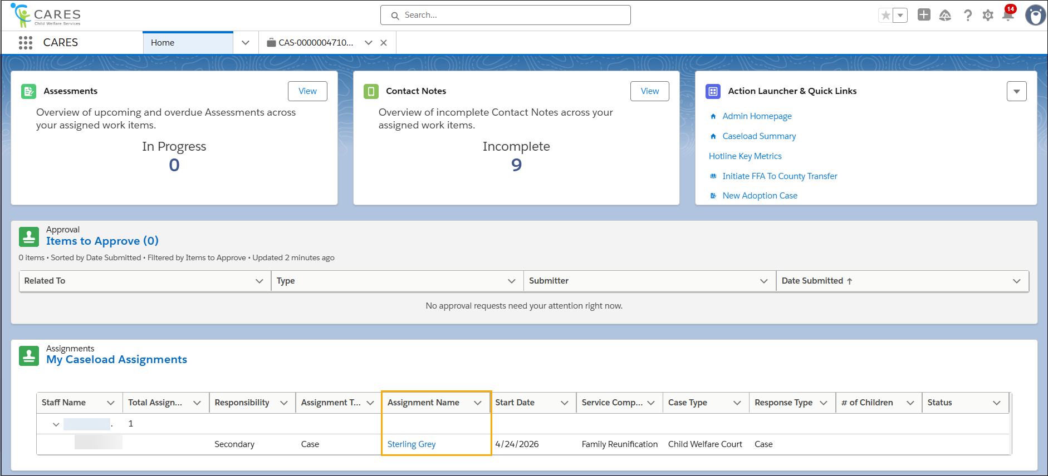
STEP 2: On the Case page, select the Court Work Items subtab under the Court Record tab in the left navigation panel. Existing Warrants will appear in the Warrants section.

