Serve a Warrant
In this lesson you will learn how to serve a warrant.
To serve a warrant, follow these steps:
STEP 1: Within the Court Work Item page for the Warrant, click on the Serve Attempts tab in the left navigation panel. Click on New.
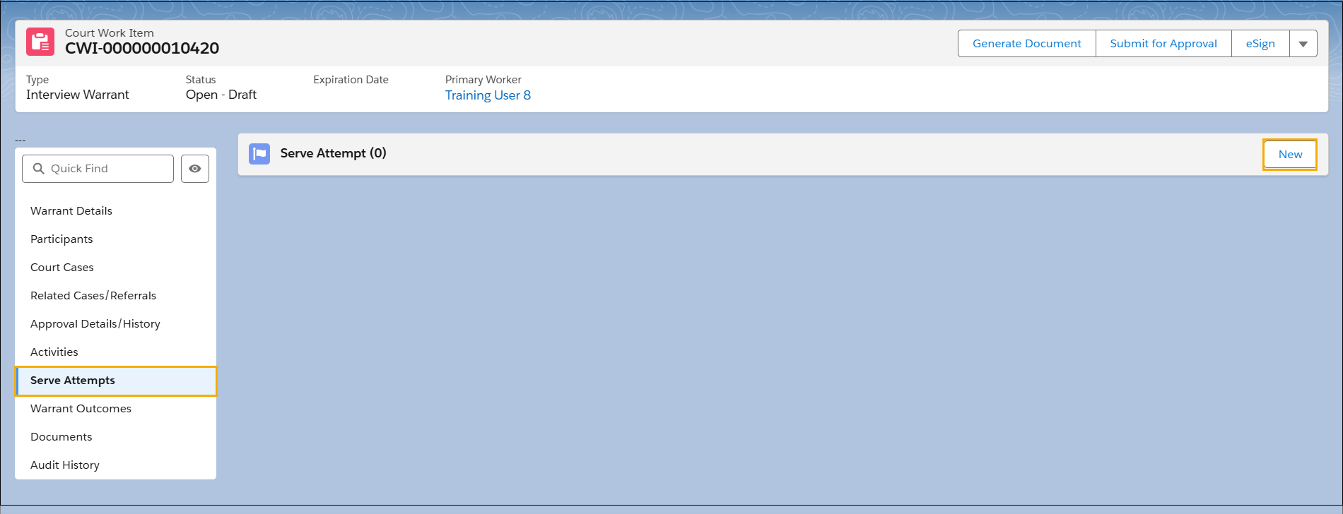
STEP 2: The Serve Attempt page displays. Select the applicable value from the Serve Attempt Successful? (Yes or No) option. Also complete the Warrant Served To field, the Serve Attempt By, and Serve Attempt Date/Time fields.
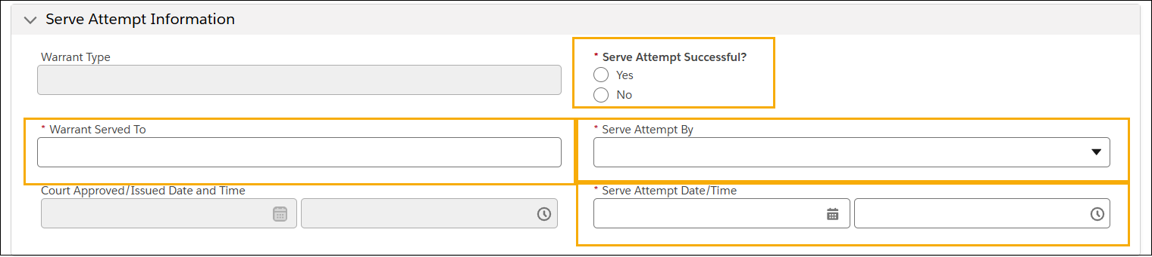
NOTE: Additional mandatory fields may appear based on selections made.

STEP 3: Complete the mandatory fields in the Address Validation section. Then click Save.
