Create a Warrant
In this lesson you will learn how to create a warrant.
To create a warrant, follow these steps:
STEP 1: On the Case Home page, select the Case Ref. ID from the Current Case Assignments section.
STEP 2: On the Case page, select the Court Work Items subtab under the Court Record tab in the left navigation panel. Click on the New button in the Warrants section.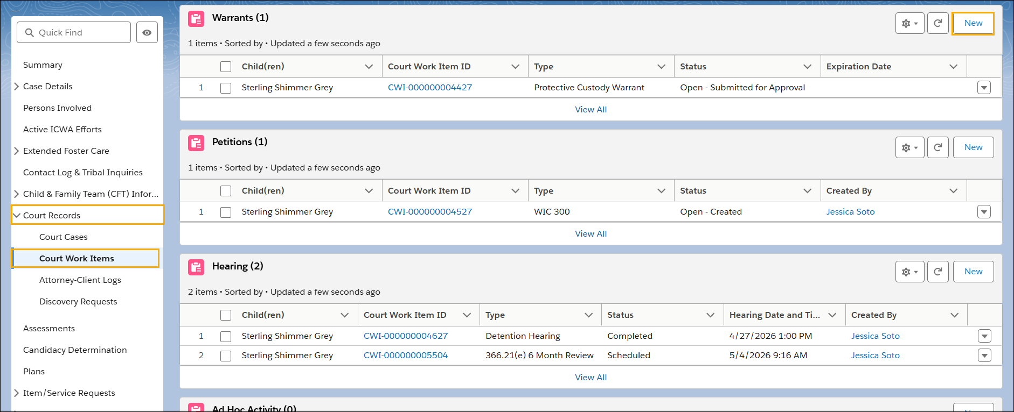
STEP 3: In the Warrant Information section, select Type from picklist list of values (Forensic Medical Exam Warrant, Home Entry Warrant, Interview Warrant, Protective Custody Warrant, Runaway or Abducted Warrant).
For a brief definition of each item in the picklist, refer to the list below:
- Forensic Medical Exam Warrant: A court order allowing a medical professional to conduct a forensic examination on a child, often to investigate suspected abuse or neglect.
- Home Entry Warrant: A court order permitting child welfare workers or law enforcement to enter a home to investigate a report of child abuse or neglect, especially if entry is being denied.
- Interview Warrant: A court order authorizing a social worker or law enforcement officer to interview a child, usually when the parents or guardians are refusing to allow the interview.
- Protective Custody Warrant: A court order allowing law enforcement to take a child into protective custody from their home or a specified location, because the child is believed to be at immediate risk of harm.
- Unauthorized Absence from Placement (UAP) or Abducted: A court order directing law enforcement to locate and return a child who has either run away from their placement or has been abducted by a parent or other individual.
STEP 4: Complete the Assigned Social Worker and Status fields. Then click Save.
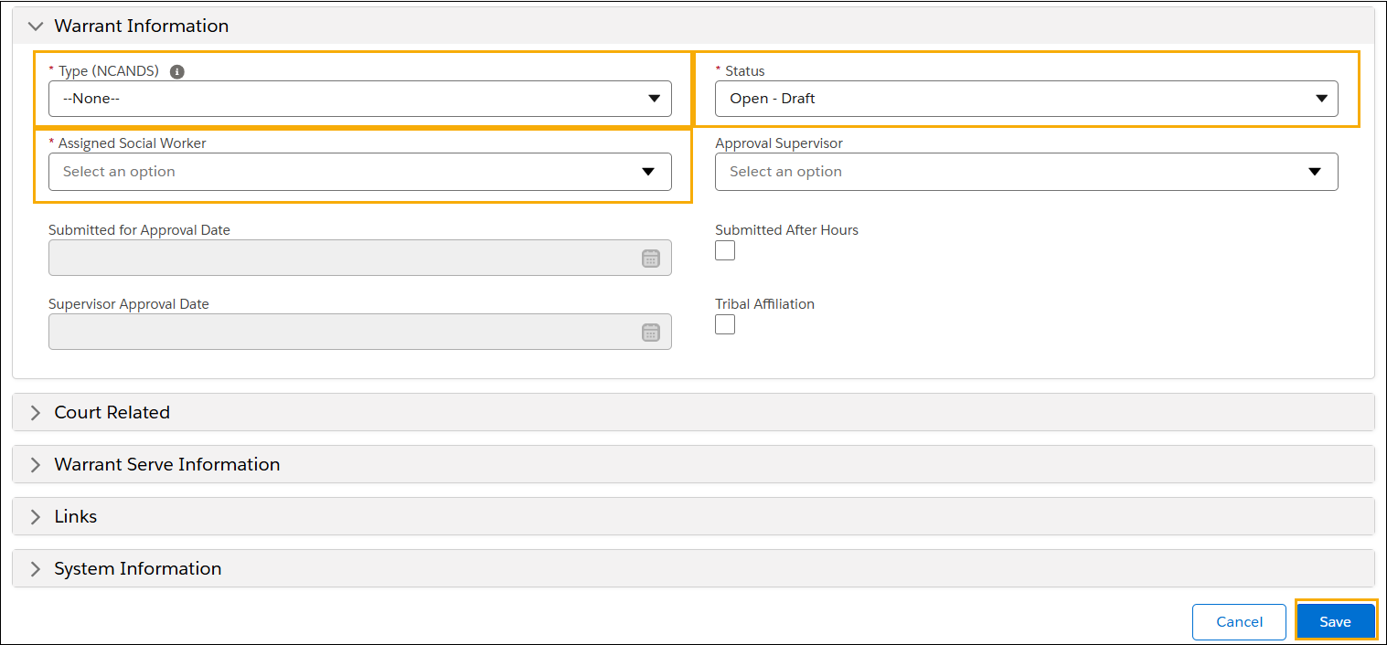
NOTE: If the focus child has a tribal affiliation or if the warrant was submitted after hours, click the applicable checkbox.
STEP 5: For cases only, if an active court cases record does not yet exist, a dialog box will appear. If this is a new Juvenile Court Case, select Yes to continue. Otherwise, select No.
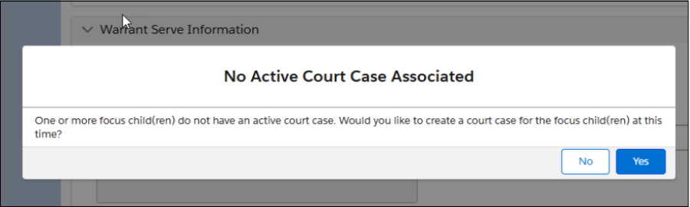
NOTE: For referrals, children must be added as participants to be included in a Warrant. Upon saving, if it is not a Juvenile Dependency Case, select No.

STEP 6: If Yes is selected, the system automatically generates and associates a Court Case ID with the Warrant. The associated court case can be viewed by navigating to Court Case in the left navigation panel.
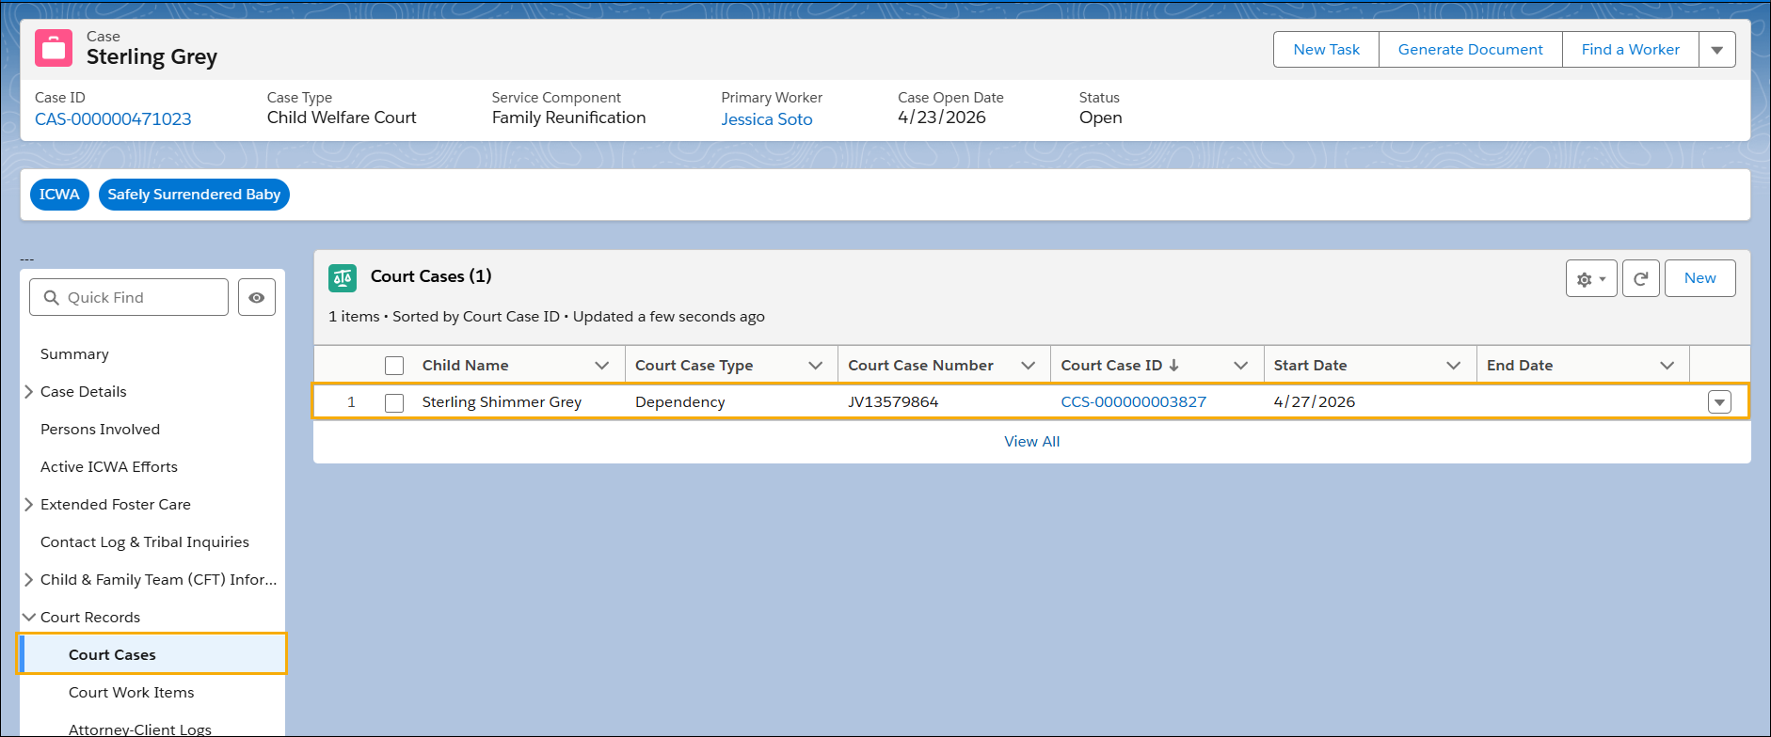

STEP 7: If No is selected, and at some future point you need to associate a court case with the Warrant, navigate to the Court Cases tab within the case and select New.
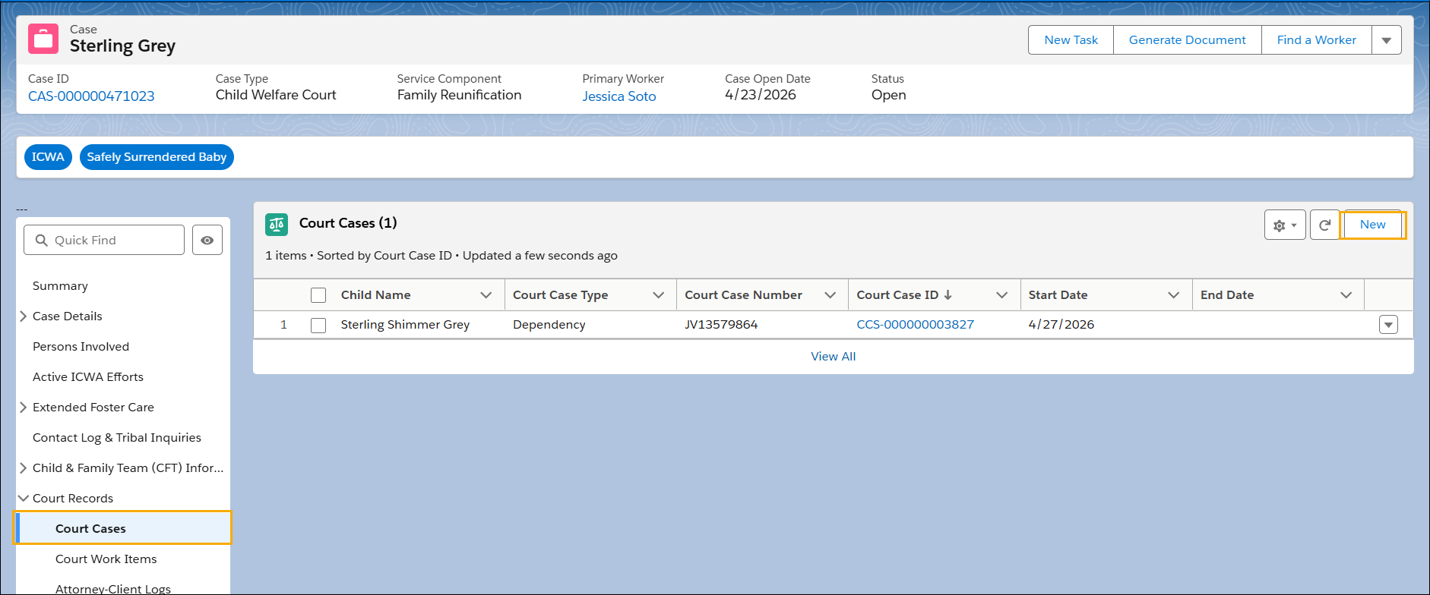

STEP 8: On the New Child Welfare Court Case page, complete the Court Case Number and Status fields. Then select Save.
