Close a Warrant
In this lesson you will learn how to close a warrant.
To close a warrant, follow these steps:
STEP 1: Within the Court Work Item page for the Warrant, click on the Warrant Details tab in the left navigation panel.
STEP 2: In the Warrant Information section, select a Closed option from the Status picklist. A description of the Closed status options are as follows:
- Closed – Court Returned/Recalled/Quashed: When one of the following scenarios occurs:
- When the Serve Attempt is successful and the court was notified.
- When a Recalled/Quashed Date is added and the court is notified.
- When the Warrant expired and the court was notified.
- Closed – Denied by Court: When the Court Ruling is “Denied”.
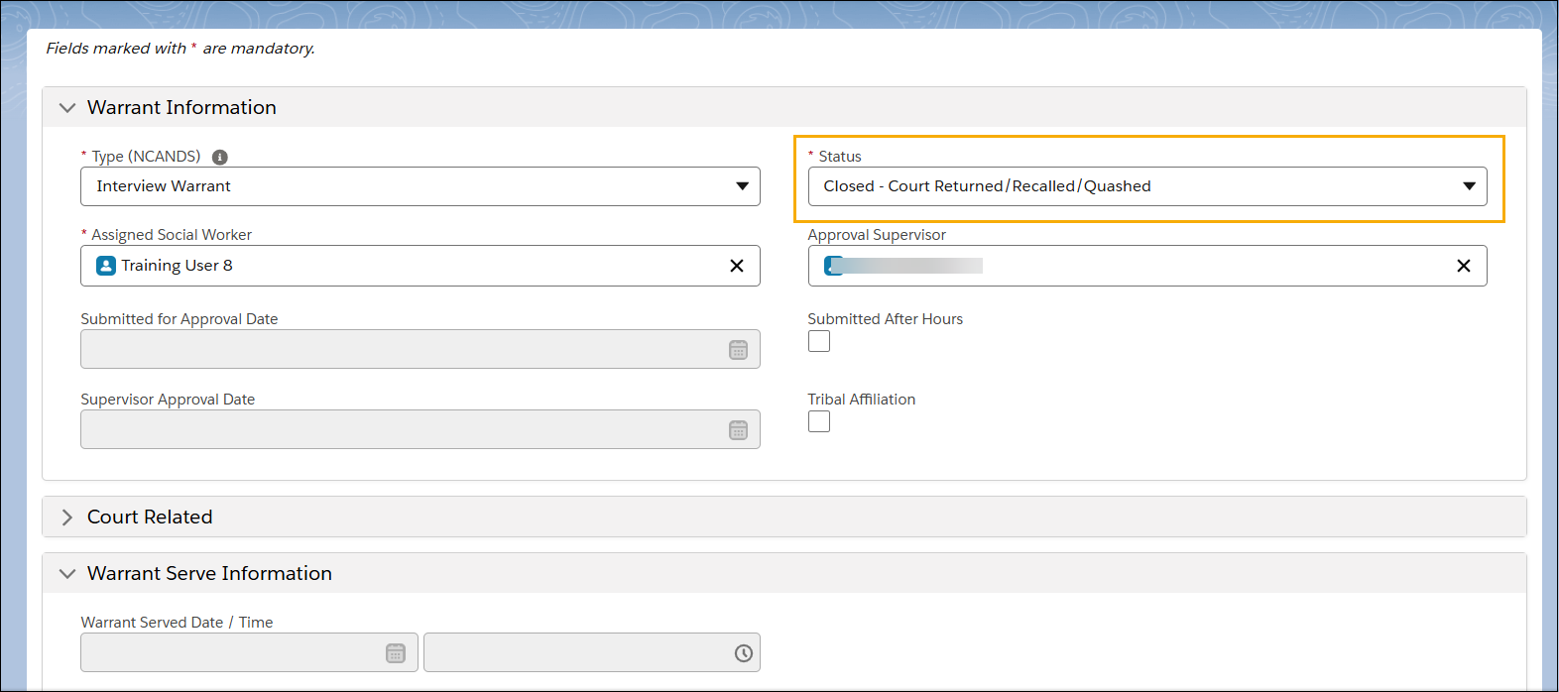
STEP 3: If “Closed - Court Returned/Recalled/Quashed” is selected, additional mandatory fields will appear within the Warrant Serve Information section. Complete the Quashed/ Recalled Method and Warrant Quashed/Recalled fields.

STEP 4: Click Save.
