eSign Documents
CWS-CARES has electronic signature functionality available for Worker and Supervisor signatures.

STEP 1: Click the eSign button in the top right corner from the desired document where eSign is available.
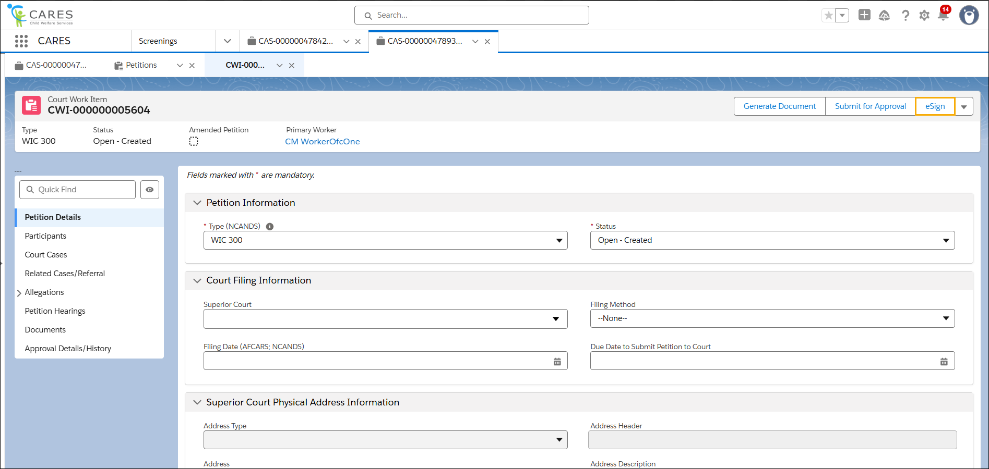
STEP 2: Select the Template Type and Document Type from the picklist. The list will vary based on the page in focus.

NOTE: Some document types may need additional external signers to sign. External signers are core participants associated with unit of work, support participants, or collaterals associated with core participants. External signers should have valid email address documented in the system.
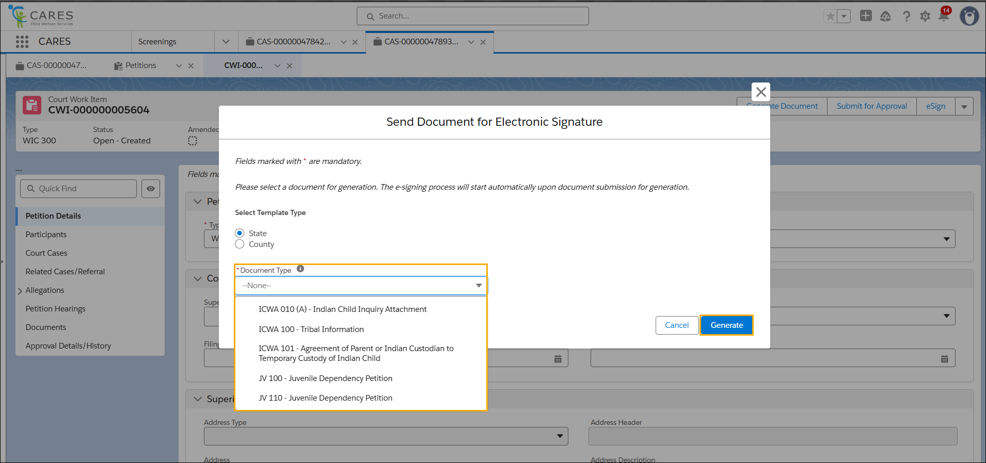

STEP 3: Click the Generate button.

STEP 4: Locate your document, and then from the dropdown menu on the right, click Edit.

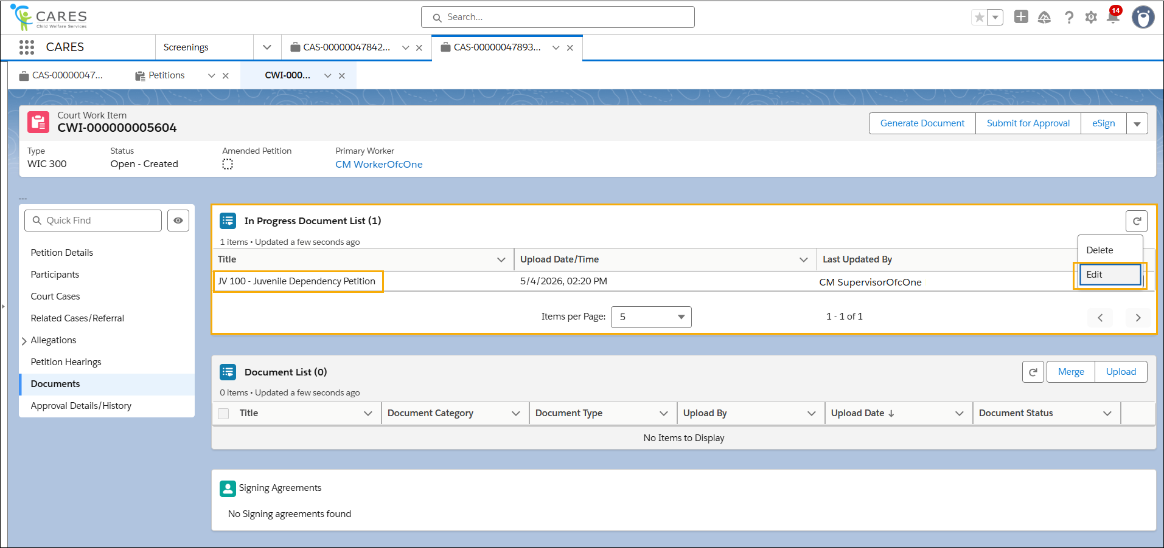

STEP 5: Click the Finalize Document button once any updates are made.

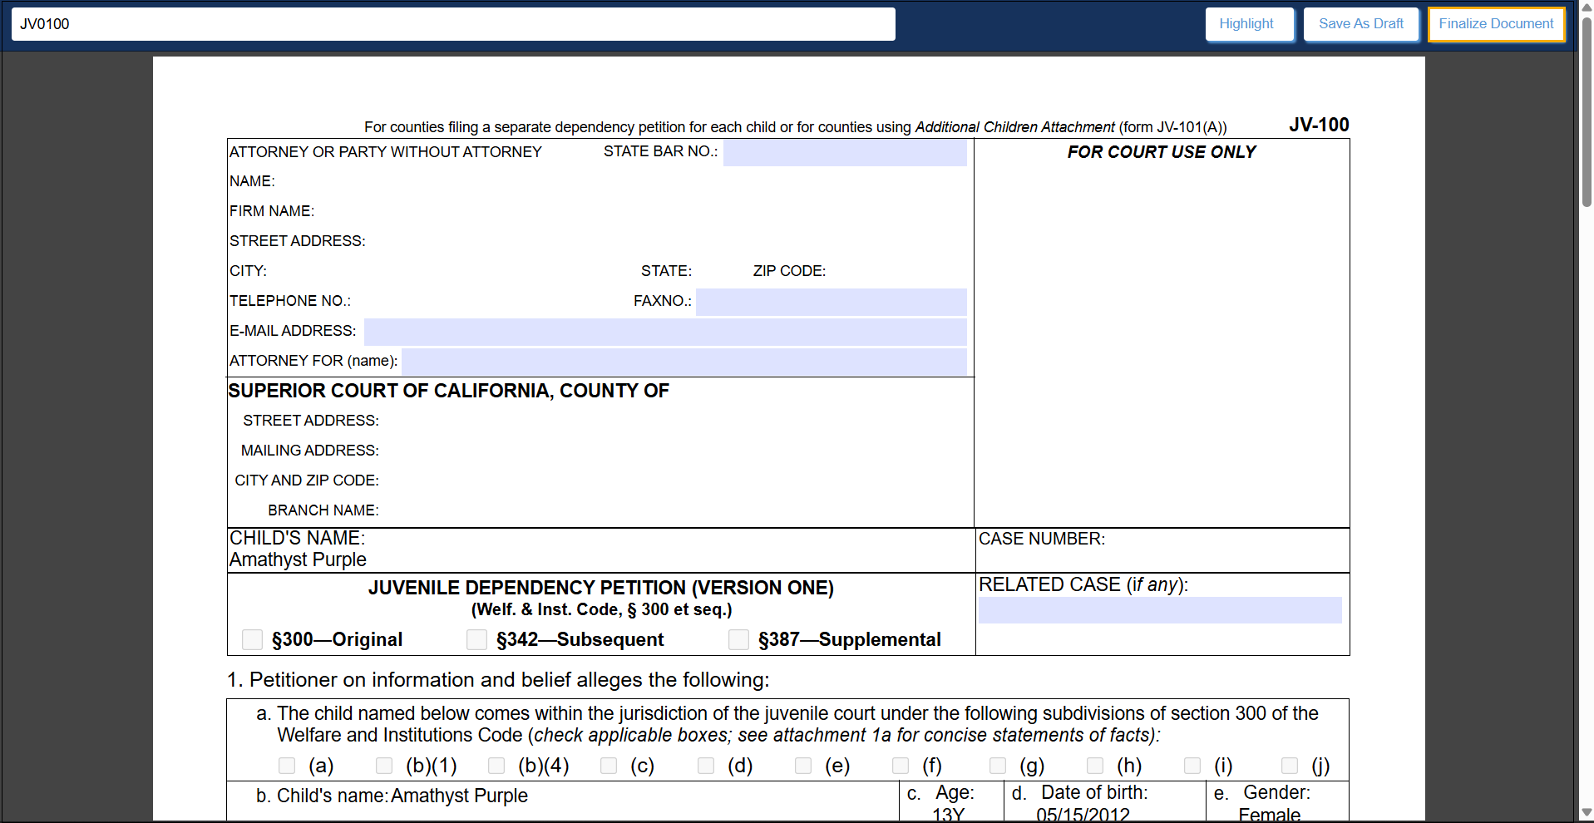

STEP 6: Click the Continue button on the bottom left.

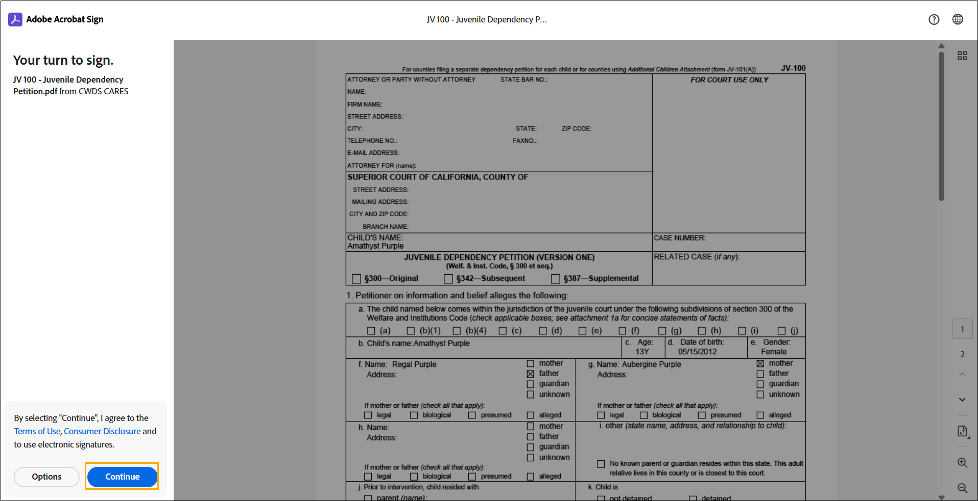

STEP 7: Click the Blue Arrow to the right of the 1 required field remaining notification.

STEP 8: Click the Click to Sign within the Signature of Petitioner field.

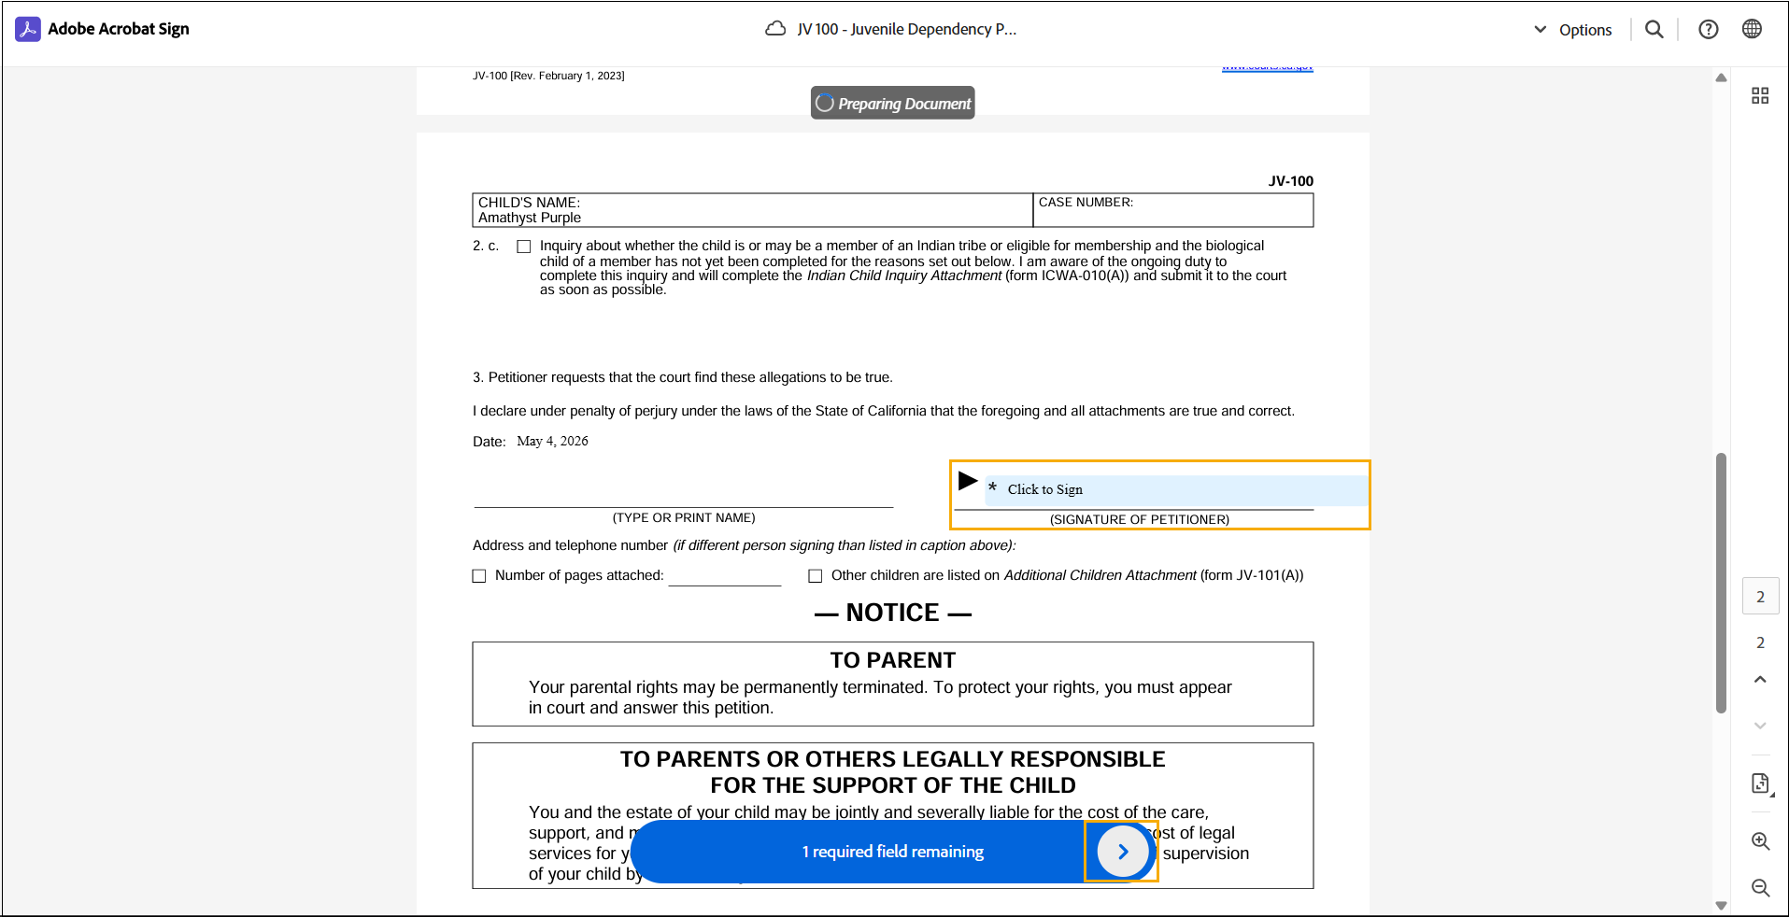

STEP 9: Complete the Signature field utilizing the options at the top: Type, Draw, Image, or Mobile.

STEP 10: Click Apply.

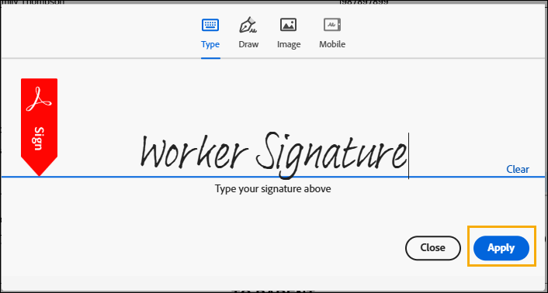

STEP 11: View the confirmation You’ve signed successfully.

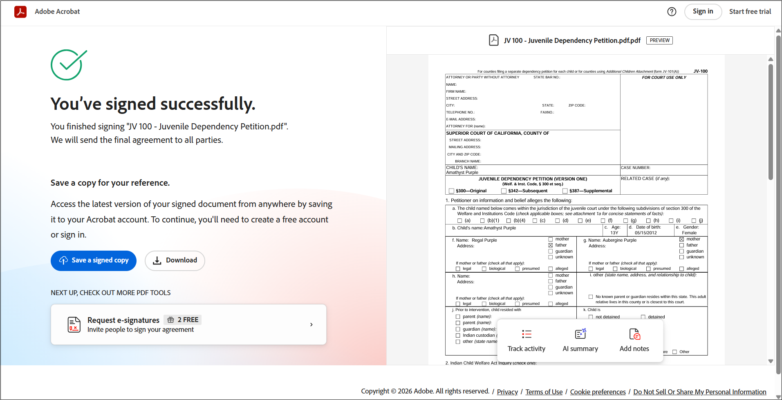

NOTE:
- The option to Save a signed copy or Download a copy is available.
- The signed document will now be available within the associated Document List.

