View Documents
CWS-CARES has various locations within the tabs and subtabs where you can View Documents.

NOTE: Your computer settings may be incorrect for this process. To ensure proper viewing, navigate to File Explorer, locate any PDF Document, right click the PDF, select Open With, select Microsoft Edge, and then select All the Time. This process only needs to be completed once.

STEP 1: Click the dropdown arrow to the right of the desired Document in the Documents tab.
STEP 2: Select View.
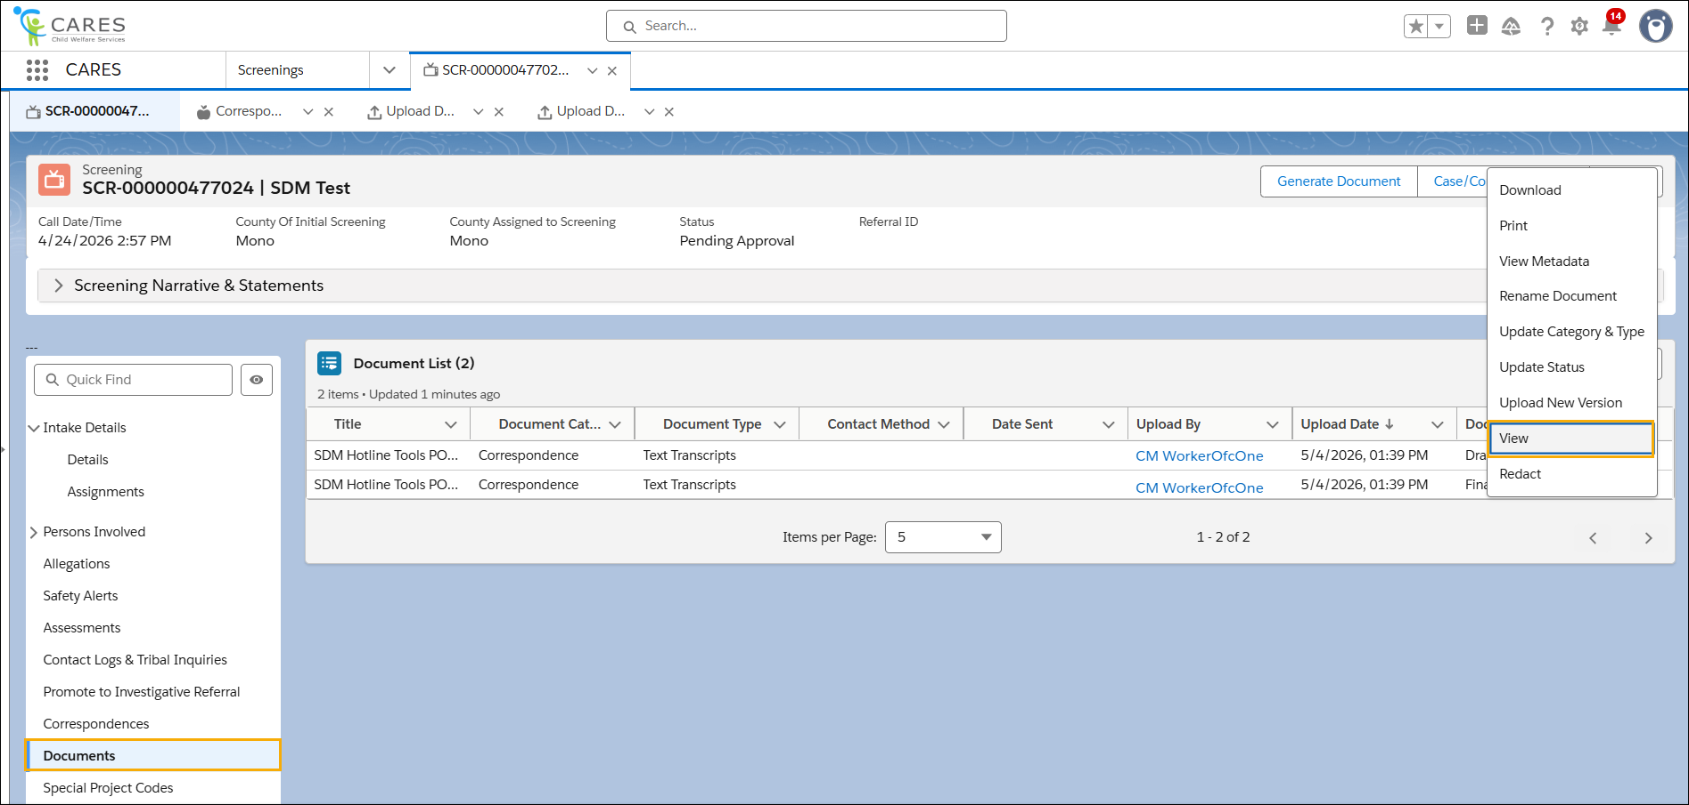

STEP 3: Click the Close button to exit the View screen.

