Redact Documents
CWS-CARES allows you to Redact Documents.

STEP 1: Click the Dropdown Arrow to the right of the desired Document in the Documents tab.
STEP 2: Select Redact.
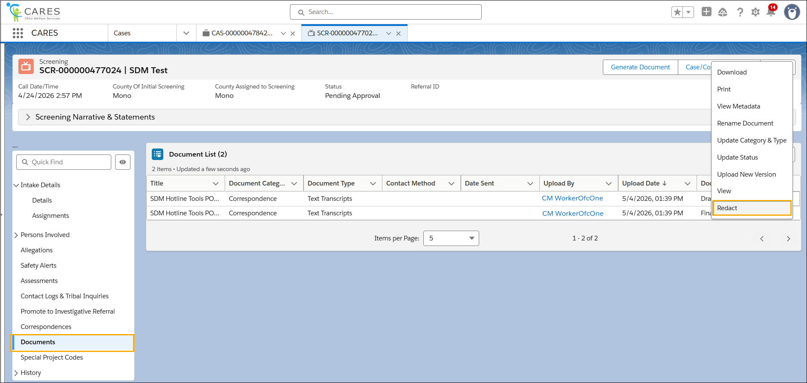

STEP 3: Populate the Reason for Redaction field.
STEP 4: Click Upload New or Upload Version, as applicable.

