Merge Documents
In Adoption and Court Work Items, the Merge Documents functionality allows you to consolidate Documents. For example, when sending several Documents to the courts for a hearing, a hearing packet can be created by merging multiple documents. This packet can then be sent electronically as a single item.

STEP 1: Select the Documents tab from the left navigation panel from within a Referral or Case.

STEP 2: Click the checkbox for two or more existing Documents within the Documents List.

STEP 3: Click the Merge button in the upper right corner.

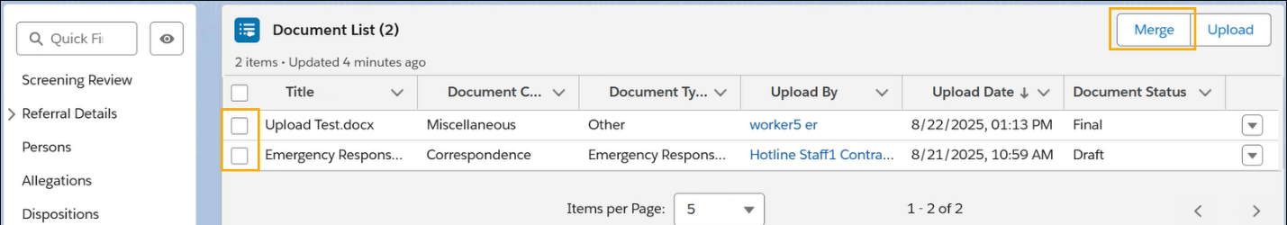

STEP 4: Enter a name for the Merged Documents in the Title field. (e.g. Document Packet)

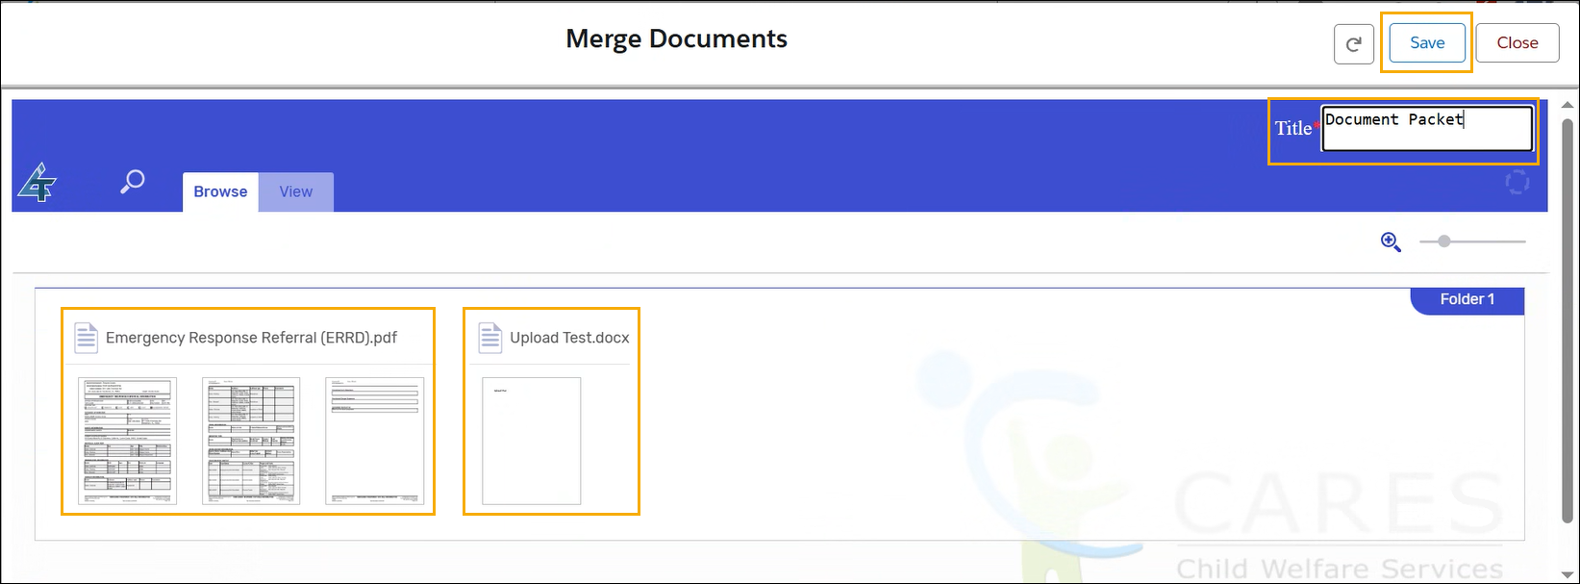

STEP 5: Select Merge With Next from the Document Tile Dropdown Menu, where applicable.

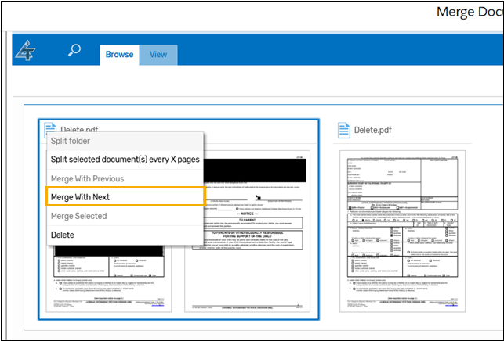

STEP 6: Click the Save button.

STEP 7: View the merged Documents in the Document List as a single item.

