Manage Documents
CWS-CARES has various locations within the tabs and subtabs where you can Manage Documents.

STEP 1: Select the dropdown arrow to the right of the desired Document in the Documents tab.

STEP 2: The following options are available to manage Documents:

- Download: Save a copy to your device.
- Print: Send the document to the printer.
- View Metadata: Metadata (or metainformation) is data that defines and describes the characteristics of other data. It often helps to describe, explain, locate, or otherwise make data easier to retrieve, use, or manage.
- Rename Document: Change the name of the document.
- Send Email: Send the document as an attachment to an email.
- Update Category & Type: Change the Category & Type of the document.
- Update Status: Identify document as In Draft, Final, or No Status.
- Upload New Version: Replace the document with an updated version.
- Redact: Block out sections of the document.

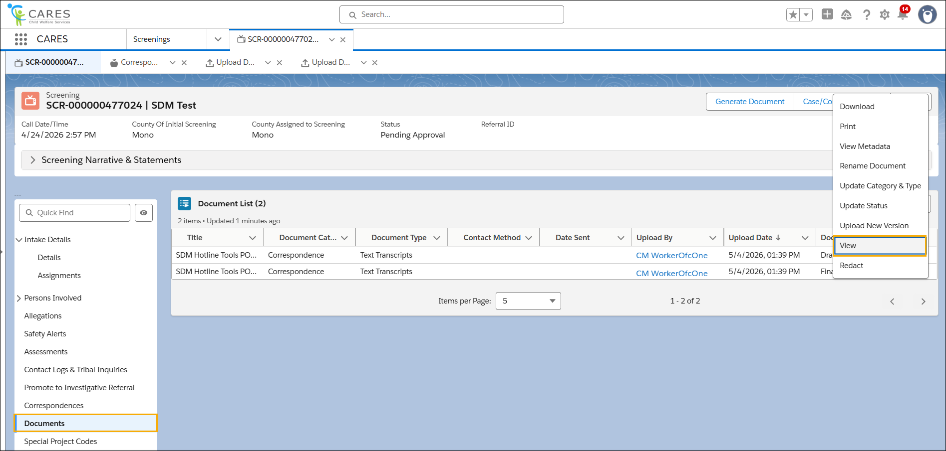

How

STEP 3: Navigate to the Document List within the Documents tab, and click the Upload button to upload a Document.

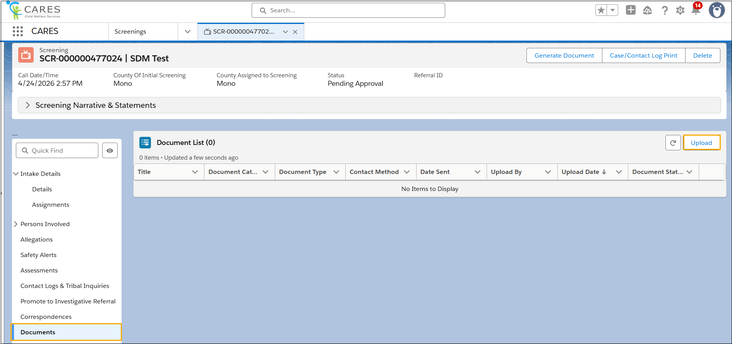

STEP 4: Complete the required fields, and then select the Upload Files button. Windows Explorer will display for you to select the desired Document from.

STEP 5: Click the Save button.

