Generate Documents
The Generate Document button is available on several pages within a Screening, Referral, and Case.

STEP 1: Click the Generate Document button in the top right corner.

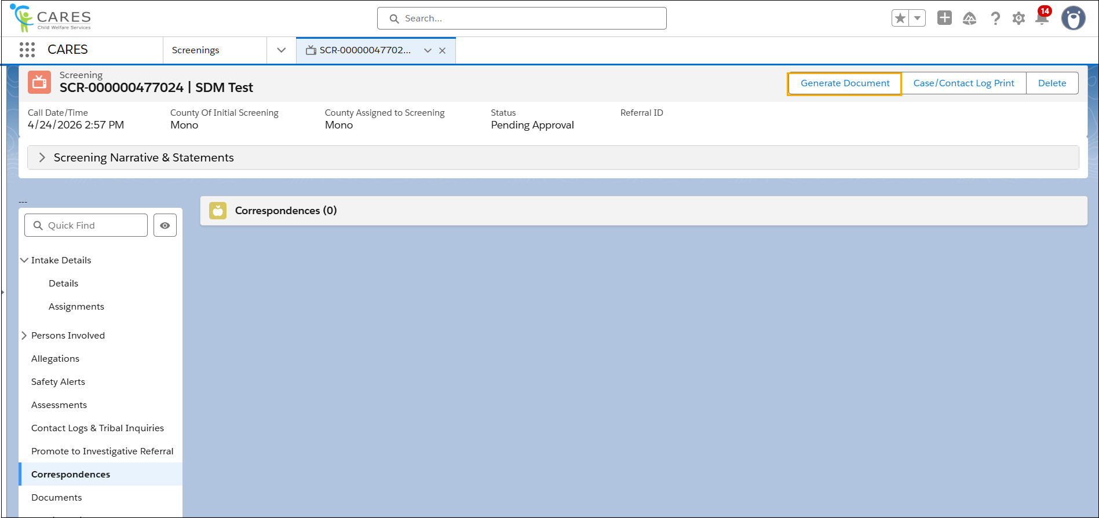
STEP 2: Populate the required fields within the Generate Document pop-up.
NOTE:
- The Document Type options will vary depending on which area Generate Document was selected.
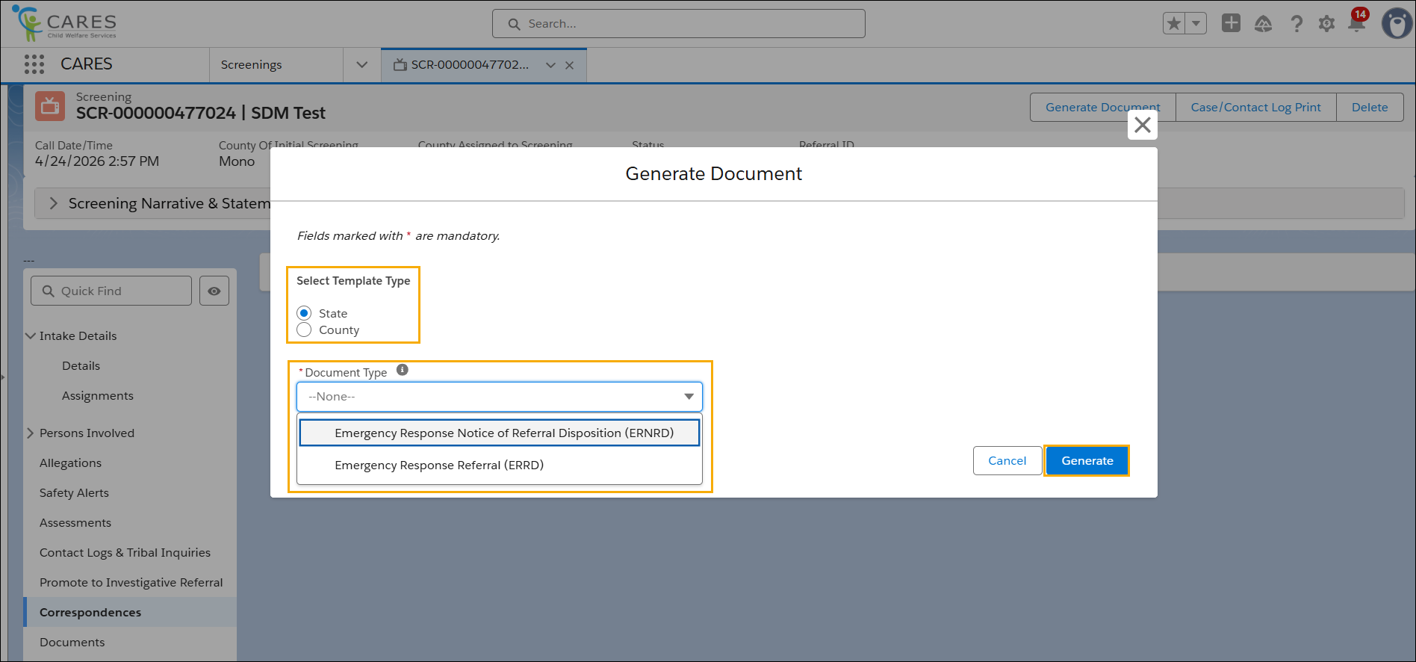

STEP 3: Click the Generate button.

STEP 4: View the newly created Document will now appear in the Document List.

