Enablement Dashboard Retrieval Guide: CARES 104 Training Environment
To access the Enablement Program Dashboard, follow these steps:
STEP 1: Start on the Salesforce Home Page. When you first log into the CARES 104 training environment, you will land on the Home Page.
STEP 2: Click the waffle at the top-left corner of the screen. Look for a small grid-shaped icon. This will open the App Launcher (the “Waffle” Icon).
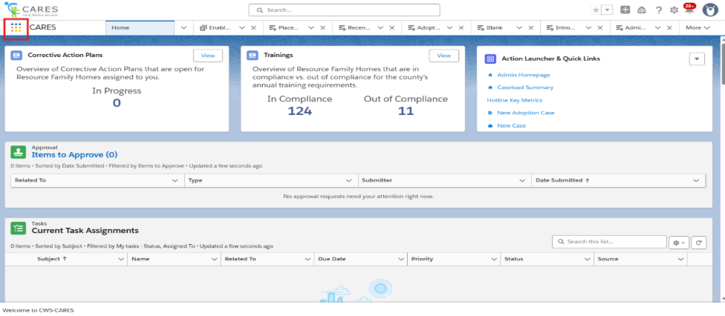

STEP 3: Type Dashboards in the search bar in the App Launder to view dashboards.
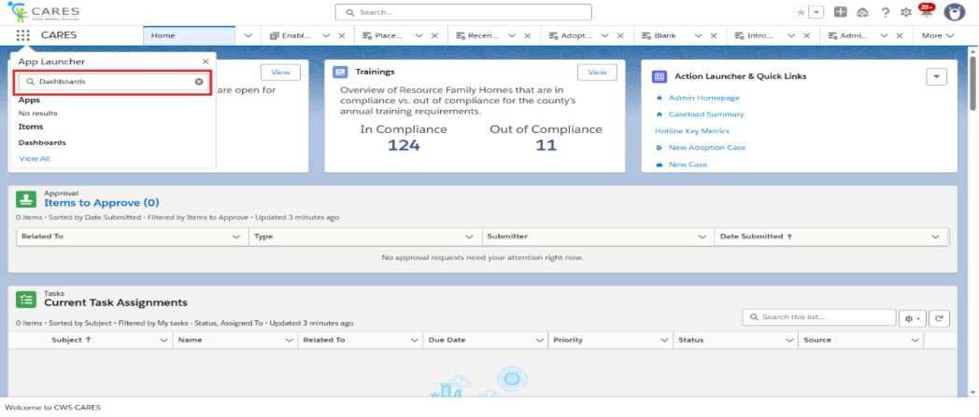

NOTE: Typing Reports will allow you to view reports.
STEP 4: Click Dashboards from the search results.
NOTE:
- When the dashboard screen opens, the first section you will see is Recent Dashboards.
- If you’ve never opened any before, this section will be empty.
STEP 5: If the Enablement Dashboard is not visible, click All Folders on the left of the screen to view all dashboards to which you have access.
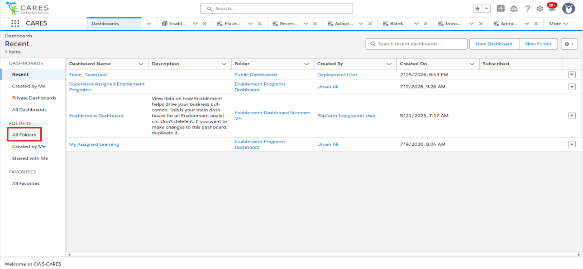
STEP 6: In the folder list, find and click the folder named Enablement Program Dashboard
NOTE: This folder contains dashboards built by Umair and used for training progress monitoring.
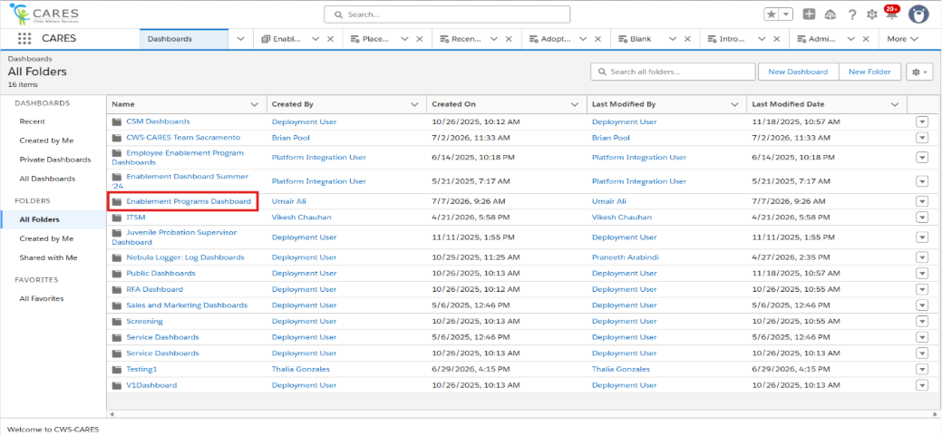
STEP 7: Click the Dashboard name listed under Name to choose the county-wide (Supervisor Assigned Enablement Program) or user-specific (My Assigned Learning) training dashboard you want to view.
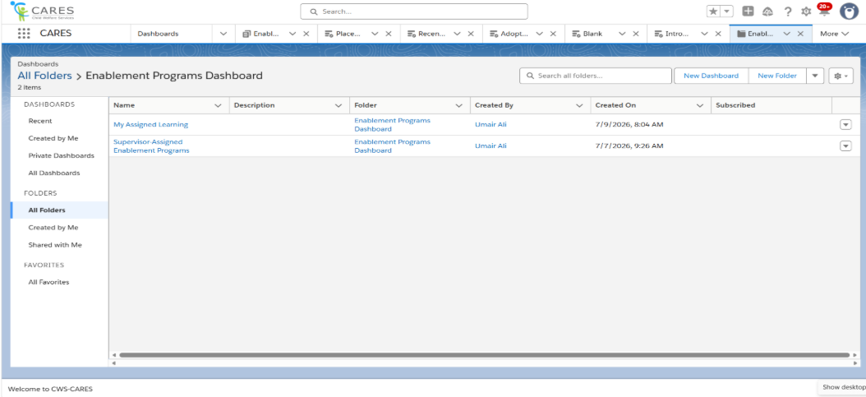

Navigating within the Enablement Dashboard

Understand the Dashboard
This dashboard will provide users a comprehensive view of their progress on the Enablement Programs.
- Assigned Learning Status: This widget will provide you a donut chart on all the Enablement Programs you have been assigned and understand what the status is of each Enablement Program.
- Learning Completion by Program: This widget will provide you a completion percentage for each of the Enablement Programs you have been enrolled in.
- Learning Completion by Lesson: This widget will provide users with a breakdown of each of the lessons completion rate within the Enablement Programs.
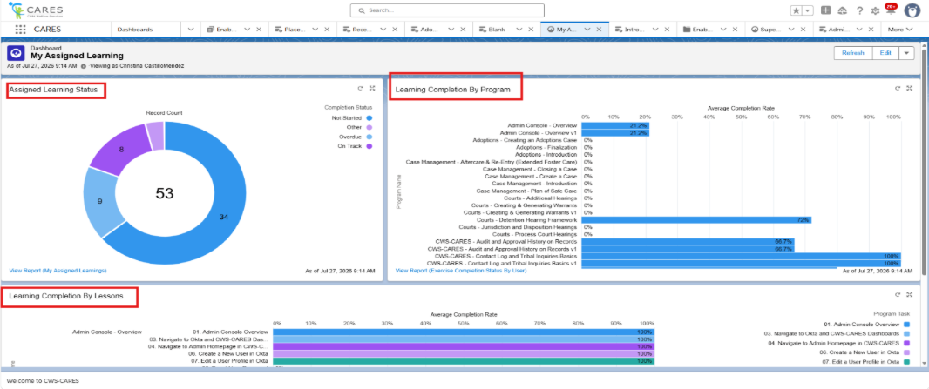

Widgets
Each box within the dashboard is called a widget. In this dashboard, they contain information about Enablement status and completion. A deeper look at the widgets available is below:

Assigned Learning Status
Within this widget you will see donut chart with the following statuses: Not Started, Overdue, On Track, or Other. The numbers within the chart will reflect the number of programs that are in this status. Keep in mind this will only demonstrate the overall status of the enablement program and not the progress on the individual lessons.
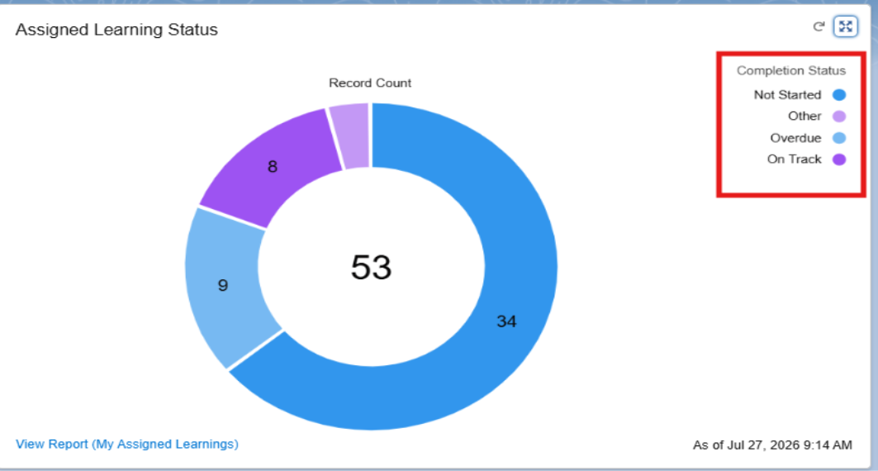

Learning Completion by Program
This widget will provide you with a completion rate percentage on all of the enablement programs you are enrolled in even the programs you have completed. If you have not begun the Enablement Program, then your completion rate will show 0%. If you have completed the Enablement Program, then your percentage will display 100%.
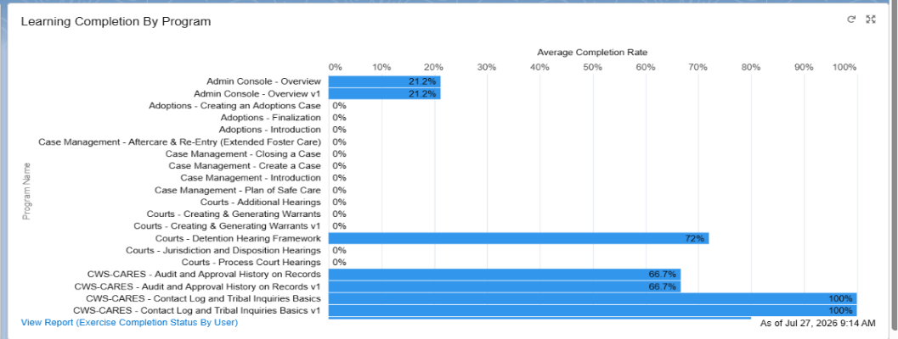

Learning Completion by Lesson
This widget will provide you a completion rate of the individual lessons included in your assigned Enablement Programs. In this widget you will see the related Enablement Program name, the lessons related to the Enablement Program, and a completion percentage of each of the lesson.
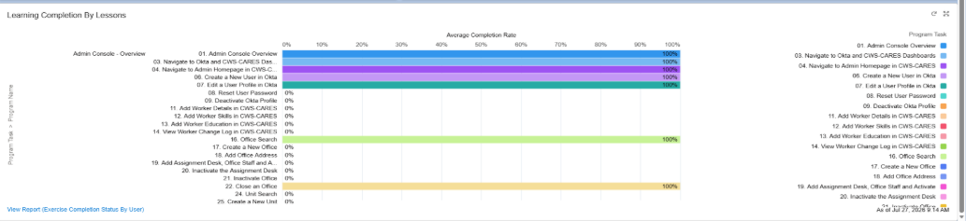
NOTE: If you are unable to view data on the dashboard, try clicking the refresh button at the top right and this should display all the related data. If you need to refresh the data on an individual widget you can also use the refresh button on the widget.
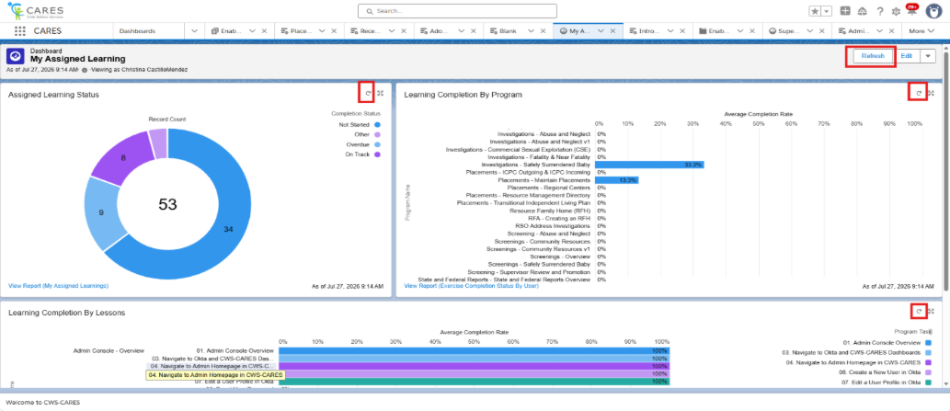

NOTE: If you need to expand the widget, click this icon and you will be able to view an expanded chart.
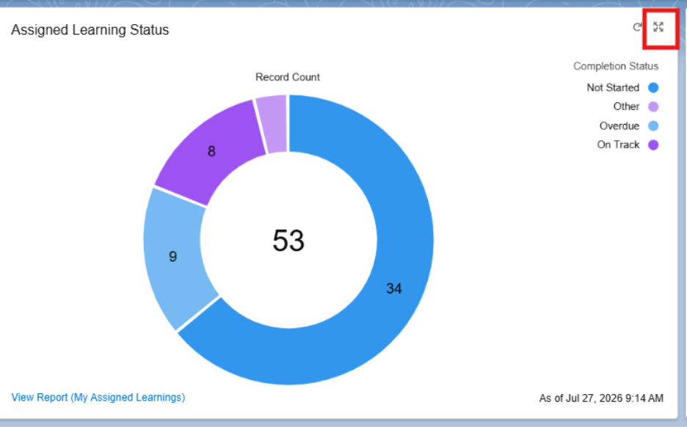

Using the Supervisor-Assigned Enablement Programs Dashboard
This dashboard will provide supervisors with a view of each user’s progress and allow supervisors to filter the user’s progress by County and/or Program Name. Users will see the following columns on the dashboard:
- Program Name: This will provide the name of the Program
- User: This will provide the name of the User who has this Enablement Program In Progress or Completed
- Email: This column will provide the email address associated with the user’s record
- Total Days: This column will provide the total days that user will have to complete the Enablement Program starting from the date it was assigned.
- Completed On Day: This column will provide how many days it took the user to complete the Enablement Program.
- Completion Rate: The Completion Rate shows the percentage of how much of the Enablement Program has been completed.
- Days in Progress: This column displays the number of days that the Enablement Program has been in progress.

Filters
There are 3 filters on this dashboard that will help you navigate the dashboard to identify the necessary information: Counties, Additional Counties, & Program Name

Counties and Additional Counties
This filter will provide a comprehensive list of the counties and display all users within the selected county with their program progress. The Additional County filter is a continuation of the County filter. If you are unable to find the correct county in the County filter, please use the Additional County filter.
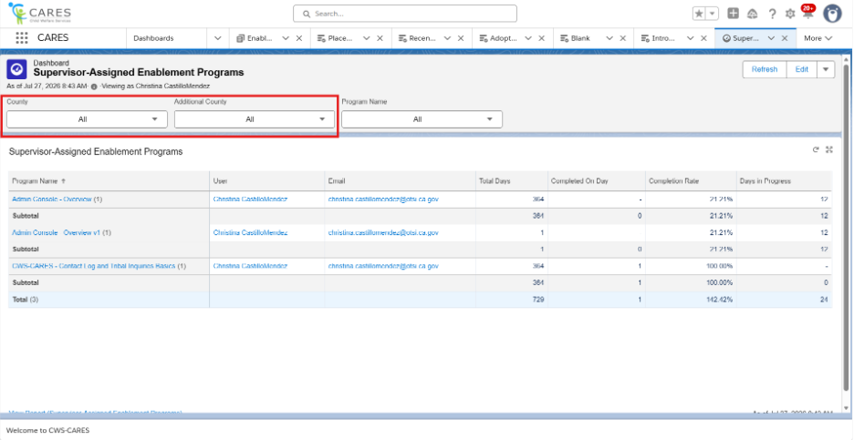

Program Name
The Program Name filter will allow you to view the user’s progress on specific Enablement Programs. This filter will provide a list of all the Enablement Programs available to users.
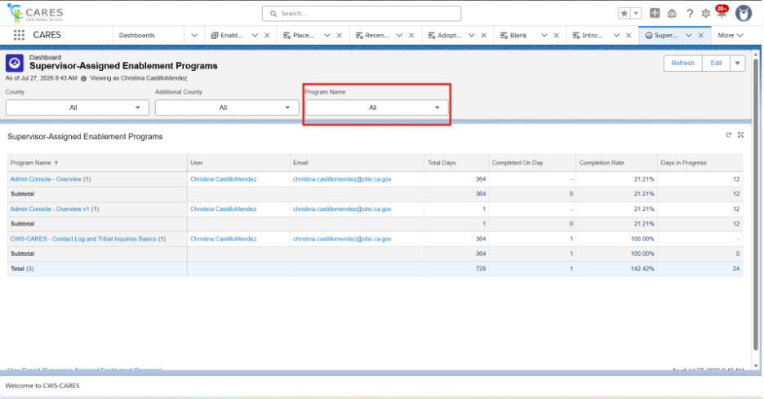
NOTE:
- If you are unable to view data on the dashboard, try clicking the Refresh button at the top right and this should display all the related data. If you need to refresh the data on an individual widget you can also use the refresh button on the widget.
- If you need to expand the widget, click this icon and you will be able to view the expanded chart.
- If you would like to navigate to the related report from the widget, you can click the link highlighted below to obtain the report.
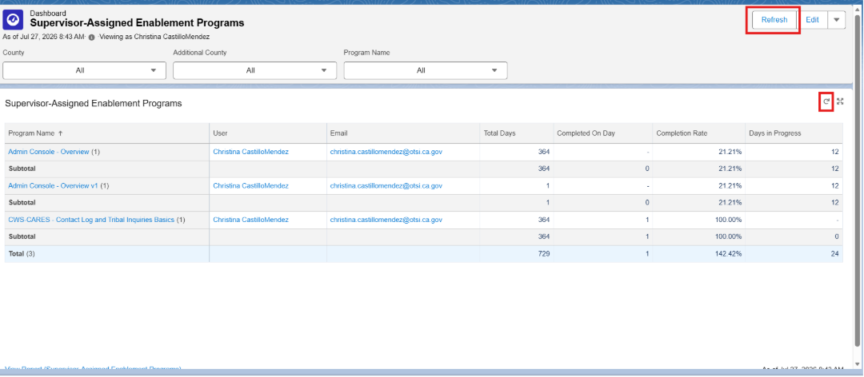

Downloading Reports
STEP 1: In the dashboard widget, click the View Report link at the bottom of the widget.
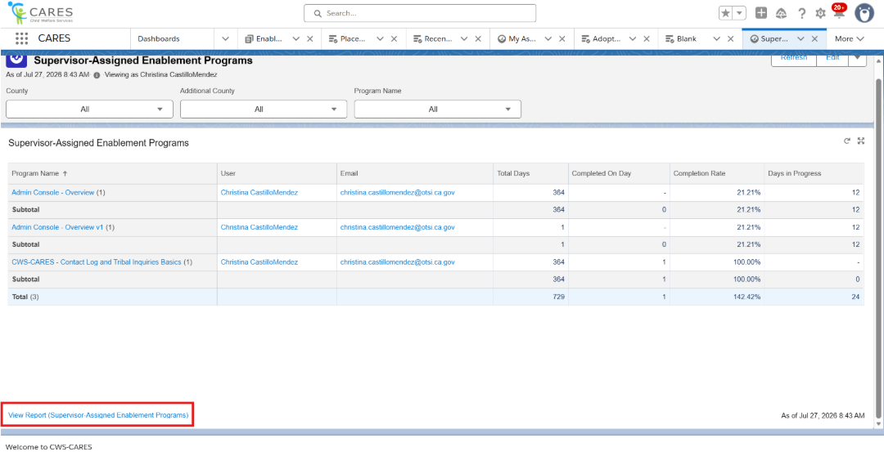STEP 2: On the report, click the drop-down carrot and select Export to download a copy of the report to your device.
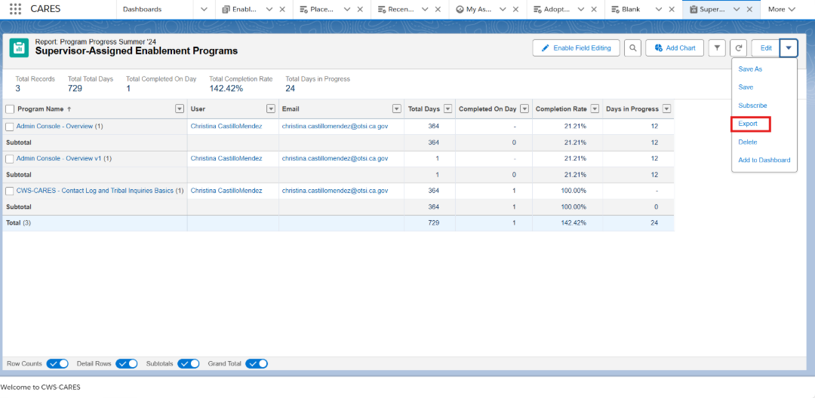
STEP 3: On the export screen, you will see the option to download a formatted report or details only. If you select the formatted report you will download a copy of the current report including groupings, report header and filter settings. If you download the details only, you will download the data of the report without the formatting. Once you decide which export view you would like, click Export.
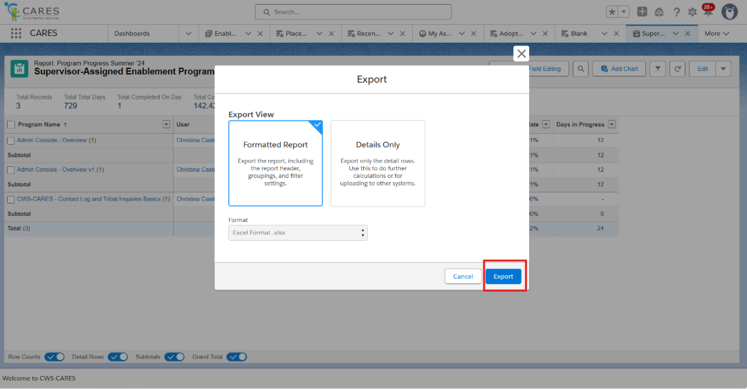
STEP 4: After clicking export, you will see a screen pop-up with the download of the report. From there you click Open file.
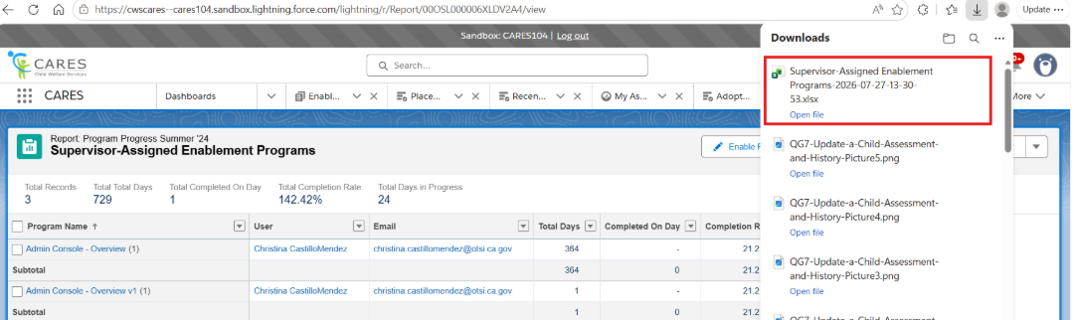

NOTE: If you click the formatted report option, your report download will look like this:

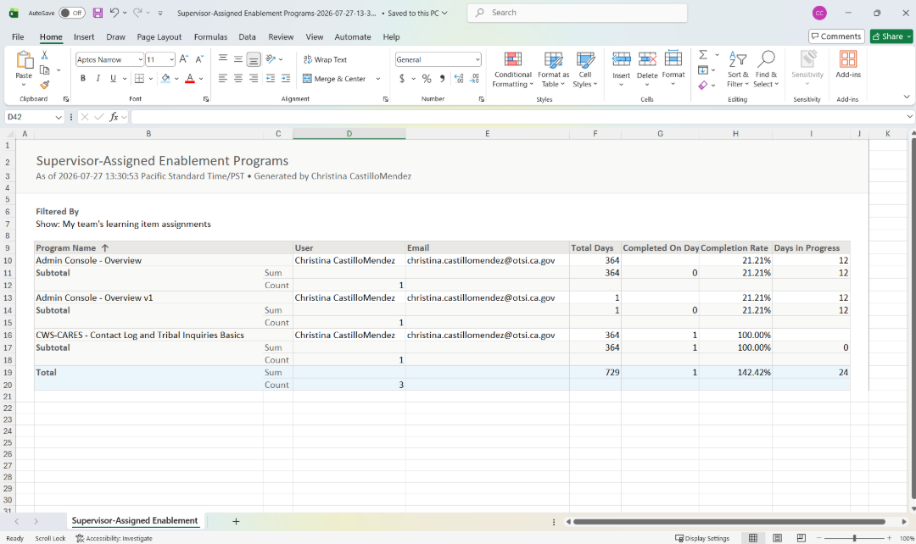
NOTE: If you click the Details Only option, your report download will look like this:
