Adoptions Case Page Overview
Purpose
This lesson will provide an overview of the Adoption Case page layout and functionality. The Adoptions Worker, Supervisor, or Manager will be able to review the information that populates into the Adoptions Case when it has been promoted from a Case Management Case Record.
After selecting an adoption case, the Adoption Case page contains the following “sections” indicated by the corresponding numbers and image below:
- Highlights Fields: The Highlights Fields are located at the top of the Adoptions Case page. This section contains the Case Name, Case ID Number, Adoption Type, Status, Closed Adoption Case Flag, Parent Case Reference Number, and Primary Worker.
- Left Navigation Panel: The Left Navigation Panel is located on the left side of the current page. The panel contains a Quick Find search function and tabs that allow the worker to view the related information. Selecting the tab drop-down arrows displays subtabs.
- Details Page: This page is located to the right of the Left Navigation Panel and displays related detailed information, sections and fields.
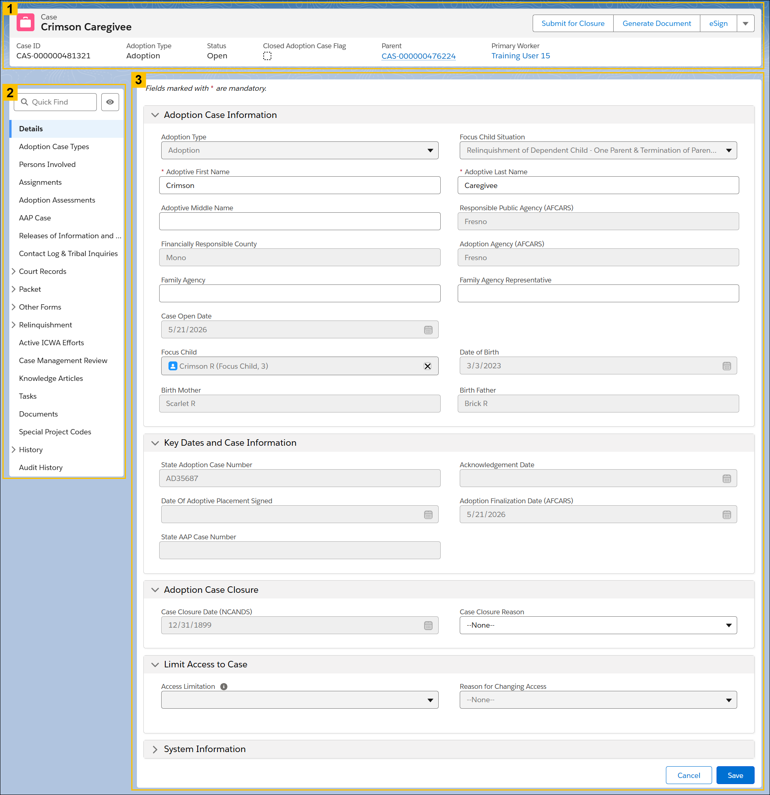

NOTE: The Left Navigation Panel tabs will vary depending on the information submitted for the Adoptions Case.

