y
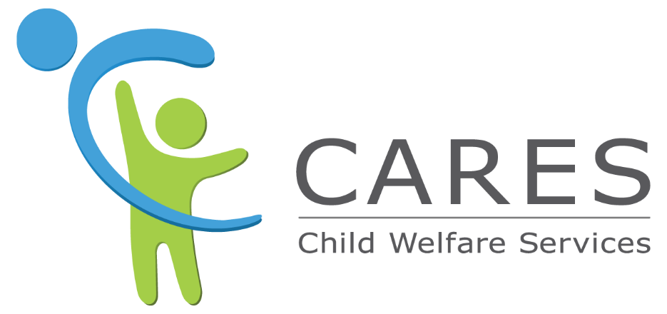

Financial Management - County Focused
Training Guide

Financial Management – County Focused Training is an instructor-led training designed for hands-on learning the CWS-CARES system within the training environment. This training phase is scenario-based and enables participants to execute key actions and business processes using data and scenarios that mirror production conditions, providing both functional and experiential readiness.

Contents
Lesson 1: Review Activity 3
Course Summary 3
Audience 3
Supporting On-Demand Learning 3
Lesson 2: Assistance Costs in CWS-CARES 3
Scenario Narrative 3
Assistance Cost Records from CalSAWS 4
External System Assistance Cost Records 5
Lesson 3: Administrative Costs in CWS-CARES 6
Scenario Narrative 6
Access DFA 600 Claims in CWS-CARES 6
Access Administrative Costs by Program Code Report 7
Lesson 4: Rate Tables in CWS-CARES 7
Scenario Narrative: 8
Viewing Rate Tables 8
Financial Management Dashboards in CWS-CARES 8

Lesson 1: Review Activity

Course Summary
This course will cover new and complex areas of CWS-CARES functionality related to Financial Management, tailored specifically for county users. This includes system features that track child-level payments, County Expense Claim Reporting Information System (CECRIS) interface data, statewide and county-specific rate tables, and service cost tracking for FFPSA.

Audience
Anyone in your county is responsible for tracking, reviewing, and approving service cost information related to FFPSA services. These users would also be able to view administrative claim information from CECRIS, assistance costs from CalSAWS and county supplemental forms, and rate tables in CWS-CARES. This functionality will be enabled in CWS-CARES through the following permissions:
- County Fiscal Workers
- County Fiscal Supervisors
- County Administrators
- CDSS Fiscal (for awareness)
Please Note: While above is our intended audience, we recommend that anyone who may benefit from and/or may be assisting in performing related activities should attend.

Supporting On-Demand Learning
The following On-Demand modules are essential learning modules available in CWS-CARES and should be complete prior to attending this ILT session.
- CWS-CARES - Audit and Approval History on Records
- CWS-CARES - Creating & Completing Tasks
- CWS-CARES - Supervisor Review and Approvals

Lesson 2: Assistance Costs in CWS-CARES
Note: CA‑800CSF is a California Department of Social Services (CDSS) form used to report Continuum of Care Reform (CCR) assistance expenditures for CalWORKs, KinGAP, and CalWORKs Diversion programs.

Scenario Narrative
A child has been removed, is placed into a new home, and their new caregiver has begun receiving assistance benefits. In real-time, CWS-CARES will receive issuance details for each payment made on behalf of their placement.
A worker needs to view what payments have been issued to the placement home, so they log into CWS-CARES and search for the child’s related case. The worker navigates to the centralized area for assistance payments on the case and is able to view the most recent payment that was issued to the caregiver.
In addition, the county made an assistance payment for the child from their general ledger, instead of CalSAWS. Therefore, they have reported the payment on their supplemental form (CA-800CSF), which was uploaded by CDSS. The payment is visible in a centralized area for assistance payments on the child’s case.

Assistance Cost Records from CalSAWS

Access Assistance Cost Records from a Case Record
To view assistance cost records in CWS-CARES:
STEP 1: Ensure you are logged into the CARES 104 Environment.
STEP 2: From the County Fiscal Worker’s Homepage, select the Cases page from the navigation panel drop-down.
STEP 3: In the list view drop-down of the Case page, select Unassigned Cases.
NOTE: If no cases appear in this list-view, have users try the Recently Viewed or Sibling Cases list view.
STEP 4: Select a Case ID from the list
STEP 5: On the Case page, select the Financial Management tab in the left-hand navigation, then the Assistance Payments subtab.
STEP 6: View the Assistance Payments table
NOTE: Due to limited connectivity with CalSAWS in 104, you may not see assistance records that are available on the case to view. Please navigate to the Financial Management Training Deck to show what an example Assistance Payment Record will look like.
STEP 5: Click the Hyperlink of the Transaction Detail Record and navigate to the specific Assistance Payment Record
STEP 6: The Assistance Payment Record will display but it will be read-only.
NOTE: Assistance Payment Records in CWS-CARES will be read only. This means that the record cannot be updated or changed within the system.

Access Assistance Cost Records from a Placement Record
STEP 1: From the left navigation panel, select the Placement tab.
STEP 2: Select the Child Location subtab then the Child Location ID link.
STEP 3: In the Child Location record, select the Assistance Payments tab in the left-hand navigation.
NOTE: This is where assigned workers will be able to view payment(s) associated with a specific placement.
STEP 4: The Assistance Payment Record will display but it will be read-only.
NOTE: Assistance Payment Records in CWS-CARES will be read only. This means that the record cannot be updated or changed within the system.

External System Assistance Cost Records
External System Assistance Payments are payment records that are not tracked/paid out of CalSAWS. This could mean that the county is making the payment out of their general ledger, or some other funding source, because the payment is not supported by CalSAWS at this time. An example of this could include Emergency Child Care Bridge (ECCB) payments.
Counties will submit information to the state about payment(s) made from another source other than CalSAWS through their monthly assistance cost reporting (i.e., CA-800). This will specifically be reported through the county-specific Supplemental Form (CA-800CSF).

Access External System Assistance Cost Records from a Case
To view external system assistance payments within a case in CWS-CARES:
STEP 1: From the County Fiscal Worker’s Homepage, select the Cases page from the navigation panel drop-down.
STEP 2: In the list view drop-down of the Case page, select Unassigned Cases.
NOTE: If no cases appear in this list-view, have users try the Recently Viewed or Sibling Cases list view.
STEP 3: Select a Case ID from the list
STEP 4: On the Case page, select the Financial Management tab in the left-hand navigation, then the External System Assistance Payments subtab.
STEP 5: View the All External System Assistance Payments table
NOTE: If a county user does not see an external assistance payment, this just means that their case does not have an external system assistance payment related to it. Records will only show here if CDSS uploads a file that contains payment information for a given case.

Access Uploaded CA-800CSF Forms
STEP 1: From the Home Page go to the Action Launcher in the right-hand Corner.
STEP 2: Select View External System Assistance Payment Transactions from the picklist.
STEP 3: Click the Transaction ID link.
STEP 4: On the left navigation panel, select the Documents tab.
STEP 5: From the Document List click the Down Carrot and select View.
STEP 6: Review CA-800 Supplemental Form.

Lesson 3: Administrative Costs in CWS-CARES

Scenario Narrative
CWS-CARES will have an interface with the County Expense Claim Information Reporting System (CECRIS) that will allow County Fiscal Workers to view their county’s DFA600 data from their County Expense Claim (CEC) on a read-only basis.
County Fiscal Departments will continue to use CECRIS to complete their CEC reporting. CWS-CARES will NOT support county administrative reporting.
NOTE: The County Expense Claim Reporting Information System (CECRIS) is a single integrated automated solution that houses the CEC and County Assistance Claim.
CWS-CARES will receive the following DFA600 claim types from CECRIS on a quarterly basis:
NOTE: Status indicates the status of the claim when we receive it in CWS-CARES. This is pulled directly from CECRIS
- Prior-to-Audit (aka Original, Status = Submitted): This will be a county’s original submission of the DFA600 report
- Audited (aka Original, Status = Approved): This will be the county’s submission of the DFA600 report after the state has provided approval.
- Adjustment: This will be the county’s adjustment claim submitted for a given fiscal year quarter
- Closeout: This is typically only used by the state. This will be generated at the end of the State and Federal fiscal year to capture any changes after the Adjustment.
NOTE: Admin Costs are NOT specific to a Case. All Admin Cost data in CWS-CARES is aggregated and specific to a statewide Program Code.

Access DFA 600 Claims in CWS-CARES
To find the county-specific CEC DFA600 records in CWS-CARES, follow these steps:
STEP 1: Navigate to the Organizations tab in the navigation panel from your homepage.
STEP 2: On the Organizations page, select the All Counties list view
STEP 3: Select your county (i.e., Mono County)
STEP 4: On the County Organization record, click the Financial Management tab, then the Administrative Claim subtab in the left-hand navigation.
STEP 5: Click on the Administrative Claim ID
STEP 6: On the Administrative Claim record, within the Details tab, users can view the following information about their county:
- Claiming Entity Number – this is pulled directly from CECRIS. This is the county’s assigned number from that system, not CWS-CARES.
- Claiming Entity – this is pulled directly from CECRIS. This is the county’s name.
- Claim Type – See note above about the different claim types.
STEP 7: On the Administrative Claim record, within the Program Code tab, users can click into a Program Code Cost ID to view specific data from the claim related to the program code.
NOTE: Each Program Code will have different fields related to the specific program code. You may see different related fields based on the Program Code Cost ID you are referring to.

Access Administrative Costs by Program Code Report
To view Administrative Costs from CECRIS in CWS-CARES:
STEP 1: From your Home Page, locate the Action Launcher & Quick Links.
STEP 3: Click the carrot icon and select the View Admin Costs by Program Codes (County Fiscal Worker Dashboard).
NOTE: CWS-CARES Users with the County Fiscal Worker or County Fiscal Supervisor permissions will be able to view Admin Cost information from their homepage.
STEP 4: From the Admin Claims & Costs with Totals section, select View Report (Admin Claims & Costs with Totals) hyperlink.
This will allow the trainee to view data specific to a Program Code from their DFA 600 report.

Lesson 4: Rate Tables in CWS-CARES
All statewide and select county-specific rate tables, like Special Care Increment (SCI), THP-Housing Supplement, and Clothing Allowance in a centralized area of CWS-CARES.
Below is a list of all the rate tables that will be visible in CWS-CARES at go-live:
- Level of Care (LOC)
- Intensive Services Foster Care (ISFC)
- Infant Supplement
- Short-Term Residential Treatment Program (STRTP)
- Dual Agency
- Educational Travel Reimbursement (ETR)
- Special Care Increment (SCI) (county-specific)
- Transitional Housing Placement – Nonminor Dependent (THP-NMD)
- THP-NMD Housing Supplement (county-specific)
- Adoptions Assistance Payment (AAP) LOC
- Age-Based AAP Basic Rates
  - Note: This will only include data from 2011-2017
- Funeral Expenses
- Parent Support Payment (PSP)
- Clothing Allowance (county-specific)
NOTE: The CDSS Rates Bureau Branch will be responsible for maintaining the rate tables in CWS-CARES. This will NOT be the responsibility of the counties.

Scenario Narrative:
A CARES User logs into CWS-CARES and would like to view a knowledge management source to view statewide and county-specific rates to identify an applicable rate for a family they are working with.
The user navigates to the Quick Links area for rate tables in the system and is able to conduct a search for the rate table they’d like to view. The user searches for the STRTP rate and is able to view current and historical rates.

Viewing Rate Tables
To view rate tables in CWS-CARES:
STEP 1: From the County Fiscal Worker Homepage, navigate to the Action Launcher & Quick Links.
STEP 2: Click View All Rates Table from the drop-down menu.
STEP 3: Click the Rate ID hyperlink to view rate table details
NOTE: Results are read only.

Financial Management Dashboards in CWS-CARES
The following rate-related dashboards will be available to users in CWS-CARES with the County Fiscal Worker or County Fiscal Supervisor permissions:
- Total Number of Children by Rate Type
This dashboard will capture all child(ren) in CWS-CARES that are actively receiving this rate type. The system will pull this information for children within an active Child Location and an active Eligibility record.
To view rate dashboards in CWS-CARES:
STEP 1: Using the navigation panel, select the Reports page.
STEP 2: Click the All Reports tab in the left-hand navigation panel
STEP 2:
NOTE: This can be found using the drop-down arrow next to CARES in the left-hand corner of your homepage

