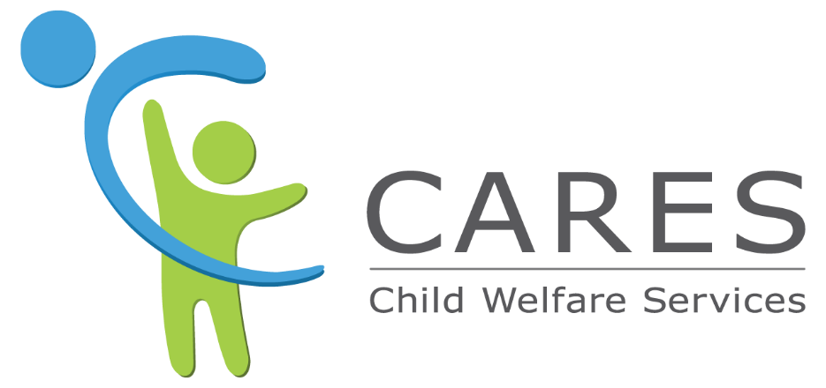

Placement Training
Guide

Placement Training is an instructor-led training designed for hands-on learning the CWS-CARES system within the training environment. This training phase is scenario-based and enables participants to execute key actions and business processes using data and scenarios that mirror production conditions, providing both functional and experiential readiness.

Contents
Lesson 1: Course Overview / Review Activity 3
Course Summary 3
Audience 3
Supporting On-Demand Learning 3
Lesson 2: Initiate Placement 4
Scenario Narrative 4
Add Birth Country to Child’s Person Record 4
Initiate Removal 5
Create a New Child Placement Needs Record 6
Create a New Parent/Guardian Placement Preferences Record 7
Create a New Tribal Placement Preferences Record 8
Search for Placement 8
Lesson 3: Emergency Placement/Pre RFA 11
Manually Create Placement 11
Create a New Contact for Placement 12
Create California Law Enforcement Telecommunications System (CLETS) and Child Abuse Central Index (CACI) Background Checks 13
Inspection 13
Document Placement Decision 14
Add Child Location 14
Generate Placement Documents 15
Generate the Notification of Child’s Placement 16
Lesson 4: Tribally Approved Homes 16
Search for a Tribally Approved Home 16
Lesson 5: Monitoring Placements 17
Scenario Narrative 17
Update Placement Stability 17
Update Placement Stability Contact 18
Creating Placement Preservation Strategy 18
Upload Placement Preservation Strategy Document 19
Create 14 Day Notice 20
Create 14 Day Notice Exemption 20
Recording Absences 21
Lesson 6: Short-Term Residential Treatment Program (STRTP) 21
Scenario Narrative 22
Initiate Removal 22
Search and Associate STRTP Placement Options 23
Create a New Contact with a STRTP Placement 24
Update STRTP Placement Option Details 25
Update STRTP Placement Decision 26
Create a New Child Location Record 26
Lesson 7: Presumptive Transfer 27
Requesting and Recording a Presumptive Transfer Waiver 27
Create a Waiver for a Presumptive Transfer Request 27
Document Waiver Request Communication 28
JV 214-Presumptive Transfer Request for Hearing on Waiver 29
End Child Location Placement 29

Lesson 1: Course Overview / Review Activity

Course Summary
This course will cover new and complex areas of CWS-CARES placement functionality. Course participants will walk through placement preferences and needs, creating placements, monitoring and maintaining placements, and presumptive transfer.

Audience
Anyone in your organization responsible for placements, placement searches, presumptive transfers, documenting absences from placement including unauthorized absences from placement and placement stability monitoring. This functionality will be enabled in CWS-CARES through the following permissions:
- Case Management Worker
- Case Management Supervisor
- Emergency Response Worker
- Emergency Response Supervisor

Note: While above is our intended audience, we recommend that anyone who may benefit from and/or may be assisting in performing related activities should attend.

Supporting On-Demand Learning
The following On-Demand modules are essential learning modules available in CWS-CARES and should be complete prior to attending this ILT session.
- CWS-CARES - Audit and Approval History on Records
- CWS-CARES - Family Transfer Request
- CWS-CARES - Contact Log and Tribal Inquiries Basics
- CWS-CARES - Creating & Completing Tasks
- CWS-CARES - Creating a Contact Note
- CWS-CARES - Creating & Managing Person Records
- CWS-CARES - Documenting Addresses
- CWS-CARES - Managing & Uploading Documents
- CWS-CARES - Managing Primary & Secondary Assignments
- CWS-CARES - Supervisor Review and Approvals
- Placements - Creating an RFH
- Placements - ICPC Incoming
- Placements - ICPC Outgoing
- Placements - Maintain Placements
- Placements - Regional Centers
- Placements - Transitional Independent Living (TIL)

Lesson 2: Initiate Placement

Accessing Data Seeded Cases
Attendees should be able to use the case they created during the Screening & Referrals course, but if there are issues, we have seeded cases for trainees in the environment.
Follow the steps below to access a data seeded Family Reunification case that can be used to complete the functionality in this lesson:
- Ensure you are logged into the CARES104 Training Environment
- From your homepage, search for your assigned Case ID in the global search
  - Note: You can get this number from your course facilitators
- Click the hyperlinked Case ID to navigate to the specific case you will use
- Click the Case Details tab on the case
- Click Assignments and select the New button in the right-hand corner
- Enter the mandatory fields
  - Responsibility: Primary
  - Caseload: Select Yourself
  - Reason for Assignment: Administrative Reason
- Click Save

Scenario Narrative
Placements are needed for Peter, age 4, and Victor, age 17, who have been removed due to Physical Abuse and General Neglect. The placement worker documents the removal of the children from their parents’ home. The worker asks the children and parents about their Placement Preferences and records the information in their cases. The Maternal Grandmother (MGM) Veronica states she can meet Peter’s Care needs. MGM shares she is unable to accommodate Victor due to his significant mental health and behavioral needs. Peter is placed with his MGM after emergency background checks are cleared and a home inspection is completed.
Peter has difficulty adapting being in placement with his MGM and the worker updates Placement Stability and works with the MGM to create a Placement Preservation Strategy that works in a short amount of time.

NOTE: Prior to initiating a Removal, the child’s country of birth needs to be documented in their Person record.

Add Birth Country to Child’s Person Record
To add the child’s country of birth, complete the following steps:
- From within the case record for the 4yr old on the left navigation panel, click the Persons Involved tab.

- On the Core Participants section, click the Person link for the focus child

- Within the Person record, on the left navigation panel, expand the Health Information tab and click on the Vital Records subtab.

- Click the Birthplace Information section and complete the following field:
- Birth Country: Select United States

- Click Save.

- Close the subtab for the Health record and navigate back to Peter’s case.

Initiate Removal
- Click the Placement Information tab then the Removals subtab on the left navigation panel.

- On the Removal section, click New.

The New Removal Details page displays.
- On the Removal Episode Information section, complete the following fields:
- Removal Date & Time: Select today’s date and time

- On the Child Removal Information section and complete the following fields:
- Primary Reason for Removal: Select General Neglect
- Environment at Removal: Select Parent Household
- Secondary Reason for Removal: Leave blank if Physical Abuse wasn’t used
- Persons Present at the Home: Select the options from the picklist
- Person who lived with the child at any point in the last 6 months: Select the options from the picklist.

- On the Removed From section and complete the following fields:
- Removed From (Person 1): Select the Father
- Removed From (Person 2): Select the Mother

- Scroll down to the Removed By section and complete the following fields:
- Removed By: Select County Agency/Staff Worker.
- County Agency/Staff Worker Name: Auto populates the worker entering the removal

- Scroll down to the Child Circumstances section and complete the following:
- Child Circumstances: Select None Apply

- Scroll down to the Family Circumstances section and complete the following:
- Family Circumstances: Select Caretaker’s Drug Use

- Scroll down to the Caretaker’s Drug Use Substance User 1 and complete the following:
- Substance User 1: Select the Mother
- Substance User 2: Select the Father

- Scroll down and click Save.

- Click the Legal Authority tab on the left navigation panel within the Removal record.

- On the Legal Authority section, click New.
The New Legal Authority page displays.

- Complete the following in the Legal Authority Information section:
- Legal Authority for Placement: Select WIC 300 a, b, c, d, f, g, i or j
- Effective Date: Date of Detention Hearing
- Click the Save button
- Click the “X” next to all open tabs to close them, until you reach the Case tab.

Create a New Child Placement Needs Record
Follow these steps to create a New Placement Needs Record:
- From the Case page, click the Placement Information tab, then click the Placement Preferences & Needs subtab on the left navigation panel
- On the Placement Needs section, click the New button.
- Complete the following on the New Placement Need record:
Child’s Information
- Child Name: Selected by default in a case.

Child’s Placement Permissions
- Permission to Share Externally Granted: Type Test or leave blank
Childs’s Desired Placement Type and Needs
- Placement Need Narrative: Type Test or leave blank
- Sibling Placement Considerations- Type Test or leave blank

Child’s Routine and Preferences
- Preferences in a Placement Provider: Type Test or leave blank
- Child's Hobbies: Type Test or leave blank
- Child's Routines: Type Test or leave blank
- Tribal Event Attendance Information: Type Test or leave blank
- Religious/Spiritual: Type Test or leave blank
- Spiritual/Religious/Cultural Activities Narrative: Type Test or leave blank
- Extracurricular or Community Activities: Type Test or leave blank
- Child Food Preferences: Type Test or leave blank
- Child Hair Care/Hair Styling Needs: Type Test or leave blank
- Fears or Anxieties: Type Test or leave blank
- Youth Employment Information: Type Test or leave blank

Child’s Needs and Challenges
- Limited Language Proficiency: Type Test or leave blank
- Mobility Challenges: Type Test or leave blank
- Independent Living Skills Training Needs: Type Test or leave blank
- Child's Transportation Needs: Type Test or leave blank
- Development Needs: Type Test or leave blank
- Other Needs: Type Test or leave blank

Child’s Behavior
- Safety Concerns: Type Test or leave blank
- Current Behavior Concerns: Type Test or leave blank
- Past Behavior Concerns: Type Test or leave blank

- Click the Save button.
- Click the X to close the Placement Preference record.

Create a New Parent/Guardian Placement Preferences Record
- From the Case page, in the left navigation panel, click the arrow to the left of the Placement Information tab then click the Placement Preferences & Needs subtab.
- On the Parent/Guardian Placement Preferences section, click the New button.
- Complete the following on the New Parent/Guardian Placement Preference record:
Source of Preference
- Child Name: Defaults to the child’s name
- Parent Guardian Name: Select the applicable parent/guardian from the picklist.
- Date Preference Identified: Enter today’s date

Step 4 Complete the following on the Preference Detail section:
- No Placement Preference (checkbox): If the parent expressed no placement preference check the box. The other fields will disappear, and the record can be Saved.
If the checkbox was not selected, proceed below.
- Non-Person Placement Preference: Type Test
- Person Placement Preference Type: Select Other
- Person Placement Preference: Enter MGM’s name
- Additional Information: Type Test

NOTE:
- Only one preference can be documented on each record, but multiple preference records can be created.
- A separate record must be created for each parent preference.

- Click the Save button.
- Click the X on the Placement Preference record to return to the main Case page.

Create a New Tribal Placement Preferences Record
Tribal Placement Preferences refers to the process of documenting the placement preferences expressed by a federally recognized Tribe for a child who is eligible under the Indian Child Welfare Act (ICWA). These preferences help ensure the child is placed in a culturally appropriate setting that supports their tribal identity, heritage, and connections.
Each Tribe establishes their own Tribal Placement Preferences in accordance with their Tribal Sovereignty. In the event the Tribe has not established a placement order, preference must be given in descending order for compliance of the Indian Child Welfare Act (ICWA):
- A member of the Indian child’s extended family.
- A foster home licensed, approved, or specified by the Indian child’s tribe.
- An Indian foster home licensed or approved by an authorized non-Indian licensing authority.
- An institution for children approved by an Indian tribe or operated by an Indian organization which has a program suitable to meet the Indian child’s needs.

- Click the Placement Information tab then the Placement Preferences & Needs subtab on the left navigation panel.
- On the Tribal Placement Preferences section, click the New button.
- Complete the following on the Tribe Placement Information section:
- Child Name: Defaults to the focus child (within a Case)
- Date of Preference Identified: Enter today’s date
- Name of Tribe: Select the applicable tribe from the picklist
- Tribe Preference Matches 25 USC 1915(b): Select Yes
NOTE:
- If No is selected from the Tribe Preference Matches 25 USC 1915(b) picklist, in the Tribe Placement Preference 1, 2, 3, & 4 fields, select the applicable preferences from their respective picklists in order of ranked priority.

- Click the Save button.
- Click the X on the Placement Preference record to navigate back to the main Case page.

Search for Placement
There are multiple types of Placement Searches. Sometimes we are searching for a home that can meet a child’s specific needs, and we need to be able to search by Placement types, locations, specializations and other criteria. In those instances, we would be searching and then associating the Placement Option to the child so we could record our contacts and decisions about placing the child.
Search fields Include:
- Location Name
- Placement Category- like congregate care, resource family homes, Other Home Based Placements, Independent Living
- Placement Type- the Placement Type options are conditional based on the Placement Category Selected
- Placement City
- Placement Zip Code
- Placement County
- Placement Specializations: If you are looking for a home Specialized in specific considerations, like physical and mental health diagnosis, behaviors, populations like LGBTQ+, military families, and refugees in which having specialized knowledge would be important to meeting a child’s needs.
- Spoken Language
The Substitute Care Provider must be created as a Core Participant in the Referral or Case and related to the Unit of Work before the provider displays in the applicable picklist. The picklist will only include the new substitute provider when the following conditions are met:
- Add the relative as a Core Participant
- Add the Substitute Care Provider and Relative roles
- Complete the applicable relationship information
- Add an Address for the substitute provider

Add the Relative as a Core Participant
- Click the Persons Involved tab on the left navigation panel.

- On the Core Participants section, click the New button.
The Person Search Criteria section displays.
- Complete the relevant fields on the Person Search Criteria section:
- First Name: Type Veronica
- Last Name: Enter a fictitious Last Name
- Sex at Birth: Select Female
- Date of Birth: Enter 04/04/1964

- Click Next.

- Scroll down to the bottom of the page and click the Add New Person button.

- On the Person Information section, update the Role field and select Relative and Substitute Care Provider.

- Scroll down and click Save.

Add Relationships To establish a Person’s Relationship
- Within the Person Involved record, click the Relationships tab on the left navigation panel.

- On the Information section complete the mandatory and relevant fields:
- Relationship Category: Select Extended Family
- Family Relationship Modifier: Select Biological
- Relationship Type: Select Grandmother

- On the Reciprocal Relationship Information section complete the following:
- Related Person: Select the 4yr old child
- Reciprocal Relationship Type: Defaults to Grandchild
- Parental Side: Select Maternal
- Start Date: For biological relationships, the start date defaults to child’s date of birth. The start date is important for Eligibility.
- Reciprocal Relationship Text: Verify the relationship is correct. If this is incorrect, update the Relationship Type on the Information section.

- Click Save.

- Repeat steps 1-4 to relate Veronica to Victor.

Add Address

- On the Person Involved banner at the top of the page, click on the hyperlink for Person “Veronica, Last Name to open her Person Record.

- Within the Person record, click on the Contact Information tab then the Addresses subtab on the left navigation panel.

- On the Active Person Addresses section click New.

- Complete the Address Information section:
- Address Type: Select Residence

- Complete the Address Validation section: Use an address within your county
- Address Line 1
- City
- County
- Zip Code

- Click Save.

- Click the X on the various tabs to navigate back to the main Case page.

Content: | Script/Talking Points:
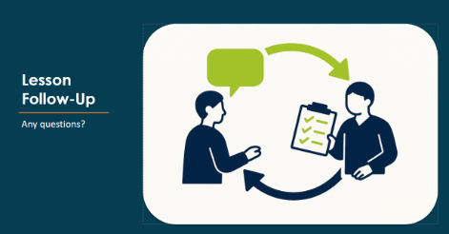 | Ask the group if there are any questions from Lesson 2

Lesson 3: Emergency Placement/Pre RFA
Content: | Script/Talking Points:
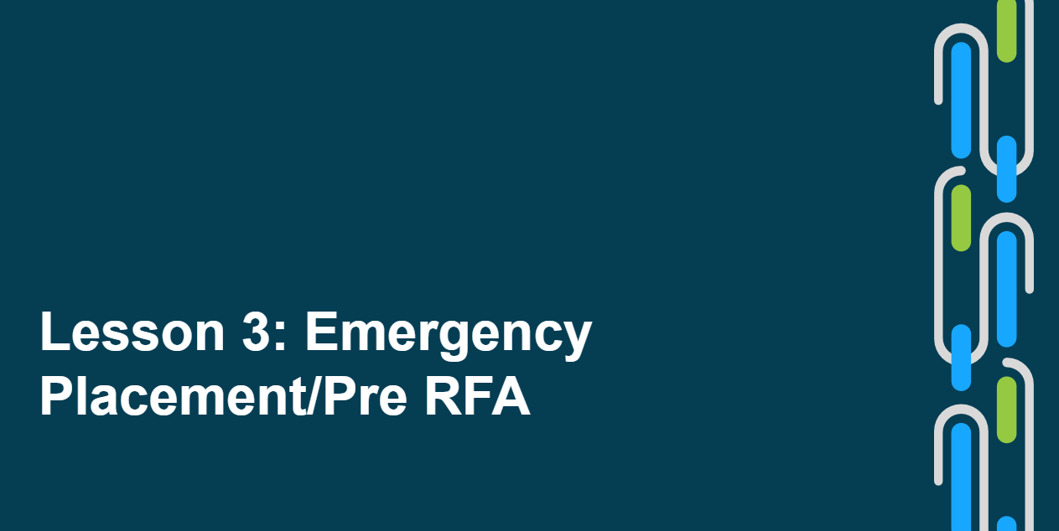 | Introduce Lesson 3  Please make the attendees aware that this Lesson is a continuation of the scenario from Lesson 2.
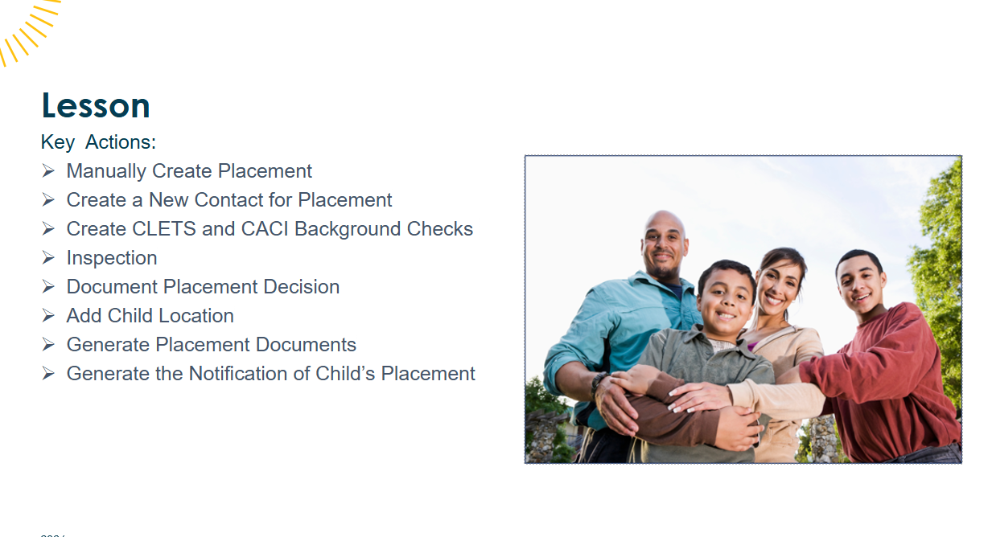 | Review the Key Actions

Manually Create Placement
Now we’re going create the Placement Option so we can document where the child is.
- Click the Placement Information tab then the Placement Search subtab on the left navigation panel.
In practice, the worker would enter all known information regarding the specific placement in the Placement Search section and click the Search button to see if the Placement already exists within CWS-CARES. If more information is entered, the search results will be more refined.

- Click the Search button.

- Click the Manually Create Placement Option.

- Complete the following on the Placement Information:
- Home/Facility Name: Type Veronica MGM
- Placement Type: Select Resource Family Home
- Primary Substitute Care Provider: Select Veronica from the picklist
- Placement Address: Select the Address Entered for Grandma from the picklist
- Emergency Placement checkbox: Select the checkbox to indicate this is an emergency placement.

- Scroll down and click the Save button.

A success notification displays.

Create a New Contact for Placement
- Click the Contact Log tab on the left navigation panel within the Provider Option record.

- On the Contact Logs section, click the New button.

- On the Contact Details section, complete the following:

- Contact Start Date/Time: Enter Today’s Date/Time
- Contact Purpose: Defaults to Consult with Other based on the contact type.
- On Behalf of Child(ren): There is a dropdown picklist, but the focus child should be listed by default.
- Participants: Select the Focus Child (4yr old child) and Substitute Care Provider (grandmother)
- Staff Person: This field defaults to the worker entering the contact, but if someone else made the contact the listed worker can be removed by clicking the X on the right side of the field and starting to type the name of the staff who made contact.
- Contact Status: Select Completed
- Contact Topic: Select Initial Placement
- Method: Select Telephone
- Documentation Status: Defaults to Final. Leave as is
- Narrative: Type Test

- Scroll down to the Additional Questions section and complete the following:
- Willing to accept placement? - Select the Yes radio button.
- Can the Placement Option provide Care?: Select Yes.
- Able to transport to school of origin?: Select the Yes radio button.

- Click Save.

- Click the “X” on the Contact Log tab to navigate back to the Provider Option page then refresh.

Create California Law Enforcement Telecommunications System (CLETS) and Child Abuse Central Index (CACI) Background Checks
Both CACI and CLETS background checks are required for each Substitute Care Provider in the Emergency Placement.
- Click the Background Checks tab in the left navigation panel within the Provider Option record.
- On the Background Checks section click the New button.
- Complete the mandatory and relevant fields in the Background Check Information section.
- Person: Select the Substitute Care Provider, Veronica, from the picklist.
- Type: Select CACI
- Requested By: This field defaults to the worker creating the Background check, like on the Contact Log, we can X out the worker and start typing a new name if someone other than the person entering the information submitted the request.
- Background Entity: Select the applicable agency from the picklist.
- Requested Date: field defaults to the current date and update it if needed. Enter the applicable date in the Received Date field when the background check results are received.
- Received Date – Today’s date
- Background Check Results: Select Clear and complete the Background Check Narrative field, if additional information should be added.
- Click the Save & New button to save the background check record, and to create another background check request.

- Complete the CLETS request for Veronica following Steps 1-3 above, with Type: CLETS
- Click Save.

NOTE: If there were other adults in the home we would repeat Steps 1-5 for each person.

- Click the X on the Background Check to close the record and navigate back to the Provider Option record.

Inspection
- Click the Inspections tab in the left navigation panel within the Provider Option record.

- On the Inspections section, click the New button.

- Complete the Inspection Information section:
- Person: Select the substitute care provider, Veronica, from the picklist.
- Reinspection Required: Select the No radio button
- Is the Home Safe? Select Yes
- Are the Child’s Care Needs Met: Select Yes.

- Click the Save button.

- Click the X on the Assessments tab to close the record and navigate back to the Provider Option record.

Document Placement Decision
- Click Placement Decision in the left navigation panel from the Provider Option record.
- Complete the mandatory and relevant fields in the Placement Decision section:
- Will the Placement Proceed? Select Yes.
- Decision Date: Select today’s date
- Staff Present: The worker entering the Placement is added by default.
- Participants: Select the parents from the picklist.
- Decision Narrative: Type Test
- Click Save.

NOTE: Notice that the highlight panel now shows a Placement Option Determination Status of Accepted.

- Click the X on the Provider Option tab to navigate back to the main Case page.

Add Child Location
To add the Child Location:
- Click the Placement Information tab, then the Child Locations subtab on the left navigation panel.
- On the Child Locations section, click New.
- On the New Child Location section, select the Placement radio button.
- Click Next.
- On the Placement Information section, complete the following:
  - Home/Facility Name – Select the placement option for Veronica from the picklist.
  - Emergency Placement- Auto-populated
  - Start Date – Enter the date of the Emergency Placement.
  - Placement Relationship – Select Relative.
- Scroll down to Provider Information section and complete the following:
- Primary Substitute Care Provider – Defaults to Veronica, but if it doesn’t select the Primary Substitute Care Provider’s Name from the picklist
- Scroll down to Additional Placement Details section and complete the following:
- Are All Siblings Placed Together? – Select Placed with None based on our scenario for Peter and Victor.
- Reason(s) Siblings Not Placed Together: Select SCP Unwilling or Unable to Care for All Siblings
- Complete the mandatory fields on the Payee Address Information section:
- Same Address as Placement Address: Select Yes radio button
- Payee Address Start Date: Click in the field and select today’s date

- Scroll down and click Save.

NOTE:
- A message Displays to Add Placement Rates, click the “X” to close the pop-up and Child Location tab to return the Child Location section page displays the recorded information.
- Verify the Child Location section displays the recorded information.
- Placement rates are added to a Child Location record and will then display on the Eligibility record.

Generate Placement Documents
Placement Documents can be generated in the Child Location record in CWS-CARES for wet signatures, or they can be eSigned.
- Within the Child Location record, click the Generate Document button in the top right corner of the banner.

- Complete the following fields:
- Select Template Type = Defaults to State. Leave as is.
- Document Type = Select SOC 156 - Agency - Foster Parents Agreement Child Placed by Agency in Foster Home
- Please Select Document Language = Defaults to English. Leave as is.

- Click Generate.

- Click the Documents tab on the left navigation panel within the Child Location record.

- Verify that the generated SOC 156 - Agency - Foster Parents Agreement Child Placed by Agency in Foster Home is available under the In Progress Document List section.

- Click the dropdown arrow next to the document and click Edit.

- Click Finalize Document on the upper right corner.

- Verify the generated SOC 156 - Agency - Foster Parents Agreement Child Placed by Agency in Foster Home is available under the Document List section.

- Click the X on the Child Location record and navigate back to the Case record.

Generate the Notification of Child’s Placement
When a child is placed, a notification of placement can he generated within the Child’s Case in CWS-CARES.
- From the child’s Case record, click the Generate Document button on the top right corner.

- Complete the following fields on the Generate Document pop up:
- Select Template Type = Defaults to State. Leave as is.
- Document Type = Select Notification of Child’s Placement
- Please Select Document Language = Defaults to English. Leave as is.

- Click Generate.

- Click the Documents tab on the left navigation panel of the Case record.

- Verify that the generated Notification of Child’s Placement is available under the Document List section and is in Draft status.

- Click the dropdown arrow next to the document and click View.

- Click the X on the View Document tab to navigate back to the main Case page.

Lesson 4: Tribally Approved Homes

Search for a Tribally Approved Home
Demo only. The trainees will not be walking through these steps in the system.
- Click the Placement Information tab then the Placement Search tab on the left Navigation Panel.

- On the Placement Search section, complete the following:
- Placement Category: Select Other Home-Based Placement
- Placement Type: Select Tribally Approved Home
- Placement County: Select your County

- Click Search.

- On the Location Search Results section that display below, click the checkbox to the left of a selected Location Name of your choice.

- Upon clicking the checkbox, the buttons at the bottom change and Associate and New Child Location buttons display.
A TAH is a home licensed or approved by an Indian child’s tribe/tribal agency or a tribe/tribal organization designated by the Indian child’s tribe. These homes can be entered in Resource Management by Tribe users with RM permissions.

Lesson 5: Monitoring Placements

Scenario Narrative
As a refresher, in our scenario...
Peter has difficulty adapting to his new placement and the worker updates Placement Stability and works with the MGM to create a Placement Preservation Strategy that works in a short amount of time.

Update Placement Stability
Placement Stability refers to the consistency and continuity of a child’s placement within the child welfare system. It tracks whether the child remains in the same care setting or experiences multiple moves to different placements over time.
NOTE: Emergency Workers, Emergency Supervisors, Case Managers, and Case Manager Supervisors should all have the same permissions in CWS-CARES to monitor the placement.
- Click the Placement Information tab then the Child Locations subtab on the left navigation panel.

- On the Child Locations section, click the Child Location ID link for the MGM.

- On the Child Location record, click the Contact Log tab on the left navigation panel.

- On the Contact Log section, click New.

- On the New Contact Log section, select the Placement Stability radio button.

- Click Next to continue.

- Complete the following mandatory fields in the Contact Details section, as well as any other relevant fields:
- Contact Start Date/Time: Select today’s date
- Contact Purpose: Select Placement Stability
- Documentation Status: Defaults to Final. Leave as is.
- Participant: Select the substitute care provider from the dropdown picklist
- On Behalf of Child(ren): Select the focus child
- Method: Select Phone.
- Narrative: Type Test

- Complete Placement Stability section:
- Date of Reported Instability: Select today’s date
- Describe Placement Concerns: Select today’s date
- Describe Placement Concerns: Type Test

- Click the Save button.

Update Placement Stability Contact
To update a Placement Stability Contact, follow these steps:
- Within the Child Location record, click the Placement Stability tab in the left navigation panel.

- Click the dropdown arrow at the end of the row of the desired Placement Stability ID link.

- Click Edit.

- Complete the following relevant fields in the Pop-up window that appears:
- Is Placement At Risk? Select Yes
- Steps taken to Mitigate Placement Risk: User Created
- Describe Placement Concerns: User Created

- Click the Save button.

Creating Placement Preservation Strategy
- Click the Placement Preservation Strategy tab on the left navigation panel within the Child Location page.

- On the Placement Preservation Strategy section click the New button.

- Complete the following mandatory fields in the Placement Preservation Strategy Information section:

- Decision made by: Select CFT
- Effective Date: Enter today’s date
- Preservation Strategy Description: User Created
- Is Placement at Risk: User Created
- Steps taken to Mitigate Placement Risk: User Created
- Plan to Stabilize Placement: User Created

- Complete the following on the Placement Stability section:
- Was the Placement Preserved?: Select Yes.

NOTE: If No is selected for Was the Placement Preserved? an additional required field will appear for Reason why Placement was not preserved.

- Click the Save button.

- The Placement Preservation Strategy page refreshes, and the following additional tabs become visible in the left navigation:

- Tasks: The worker can set a task related to the stabilizing and preserving the placement.
- Audit History: The worker can view who and when updates were made to this record.
- Documents: The worker can upload any documents utilized in stabilizing and preserving the placement.

Upload Placement Preservation Strategy Document
In CWS-CARES we can upload Placement documents to the Child Location record.
- Within the Placement Preservation Strategy record, select the Documents tab in the left navigation panel.

- On the Document List section, Click Upload button.

- Complete the following mandatory fields in the Document Details section, as well as any other relevant fields:

- Document Category: Select Case Management from the picklist
- Documents Type: Select Placement Preservation Strategies from the picklist
- Documentation Status: Defaults to Final, leave as is.

- Click Upload Files and select the document you wish to upload.

- Once the file appears in the record, click Upload.

- Click the X on the tabs to navigate back to the Child Location record.

Create 14 Day Notice
- Within the Child Location record, click the Correspondences tab in the left navigation panel.

- On the 14-Day Notice section, click the New button.

- Complete the following mandatory fields in the 14-Day Notice Information section, as well as any other relevant fields:

- Recipient Name: User Entered
- Method of Distribution: Select Mail
- Distribution Date and Time: Enter today’s date/time

- Click Save.

- Click the X on the Correspondence tab to navigate back to the Child Location record.
NOTE: When the Recipient receives the Notice, the worker would reopen the 14 Day Notice Correspondence Record and update the Recipient Acknowledgement Status to Received and document Date and Time of the Acknowledgement and click Save.

Create 14 Day Notice Exemption
- From the Correspondences tab, on the 14-Day Notice Exemption section, click the New button.

- Complete the following mandatory fields in the 14-Day Notice Exemption Information section, as well as any other relevant fields:

- Date of Waiver Determination: Select today’s date
- 14 Day Notice Waiver Reason: User Entered
- Exemption Narrative: User Entered

- Click the Save button.

- Click the X to navigate back to the Child Location record.

We are going to pretend for a minute that Peter (aka the focus child) is unexpectedly hospitalized due to a high fever. He is checked into the hospital, but there is not a diagnosis, and all that the caregiver knows is that he is receiving IV fluids and will be staying overnight. The caregiver intends to bring him home when he is discharged. She provides a primary ctact at the Hospital

Recording Absences

- Within the Child Location record, click the Absences tab on the left navigation panel.

- In the Absences section, click the New button

- On the New Absence record, select the Unplanned radio button then click the Next button.

- Complete the following mandatory fields on the Child Location Information section, as well as any other relevant fields:
- Start Date and Time: Select yesterday’s date
- Reason for Absence: Select Hospitalization
NOTE: Depending on the Reason for Absence selected, additional mandatory sections and fields may appear.
- Hospitalization Type: Select Hospital Stay-Medical
- Admission Information: User Created
- Discharge Plan Summary: User Created

- Complete the Medical Hospitalization section:
- Communicable Disease: Select Unknown
- Date Reported to Worker: Select Today’s Date

- Complete the Primary Contact Information section:
- Provider Documented in RM Directory?: Select Yes
- Temporary Location Name: Select a Hospital from the picklist
- Primary Contact at Location: User Created
- Preferred Method of Contact: Select Phone
- Phone: User Created

- On the Absence Narrative section, complete the Absence Narrative field: User Created.

- Click the Save button.

- Click the X on the various tabs to navigate back to the main Case page.

Lesson 6: Short-Term Residential Treatment Program (STRTP)

Scenario Narrative
The maternal grandmother (MGM) stated she was unable to meet Victor’s need at the time of removal. The family relays that prior to intervention, Victor has had numerous psychiatric hospitalizations and is currently not stable. As a result, the worker starts the process of temporarily placing Victor in a Short Term Residential Therapeutic Program (STRTP). Since the STRTP is in another county, the worker initiates a Presumptive Transfer of these services, requesting a waiver as the placement is intended to be short-term.
After receiving specialized mental health services, the plan is for Victor to be Placed with his MGM. The MGM visits Victor regularly and decides that she wants him placed with her. All agree to this change when Victor is ready to step down

Initiate Removal
- From the open Case record, click the Placement Information tab then the Removals subtab on the left navigation panel.

- On the Removal section, click New.

The New Removal page displays.

- On the Removal Episode Information section, complete the following fields:

- Removal Date & Time: Select today’s date and time

- On the Child Removal Information section and complete the following fields:

- Primary Reason for Removal: Select Physical Abuse
- Environment at Removal: Select Parent household
- Secondary Reason for Removal: Although not mandatory, this is important information for Eligibility and should be included if there is a secondary reason. Select General Neglect.
- Persons Present at the Home: Select any persons present in the home at time of removal
- Person who lived with the child at any point in the last 6 months: Select the options from the picklist

- On the Removed From section and complete the following fields:

- Removed From (Person 1): Select the Father
- Removed From (Person 2): Select the Mother

- Scroll down to the Removed By section and complete the following fields:

- Removed By: Select County Agency/Staff Worker
- County Agency/Staff Worker Name: Auto populates the worker entering the removal

- Scroll down to the Child Circumstances section and complete the following:
- Child Circumstances: Select None Apply

- Scroll down to the Family Circumstances section and complete the following:

- Family Circumstances - Select Caretaker’s Drug Use

- Scroll down to the Caretaker’s Drug Use Substance User 1 and complete the following:

- Substance User 1: Select the Mother
- Substance User 2: Select the Father

- Scroll down and click Save.

Legal Authority
Creating the Legal Authority for a Removal refers to the formal process by which a child welfare agency establishes the legal basis to remove a child from their home due to concerns regarding the child’s safety.
The initial Legal Authority is automatically generated when the removal is saved and defaults to Legal Authority Not Yet Determined. Once the Court’s Order’s are documented in the Hearing Court Work Item in the Court Minute Orders tab, a new Legal Authorities record is created. The most recent effective date always supersedes the other dates and Legal Authorities for Placement.

- Click the Legal Authority tab on the left navigation panel within the Removal record.

- On the Legal Authorities section, click New.
The New Legal Authority page displays.
- On the Legal Authority Information section, complete the following fields:
- Legal Authority for Placement (Eligibility): Select WIC 300 a, b, c, d, f, g, i or j
- Effective Date: Date of Detention Hearing
- Click the Save button
- Click the “X” next to all open tabs to close them, until you reach the Case tab.

Search and Associate STRTP Placement Options
Search for a suitable placement provider or facility for a child in care, and; Associate or (link) the selected placement as a Placement Option
- Within an open case, click the Placement Information tab then the Placement Search subtab on the left navigation panel.

- On the Placement Search section complete the following:
- Placement Category: Select Congregate Care from the picklist
- Placement Type: Select STRTP (Short-Term Residential Therapeutic Program) from the picklist
- Click the Search button.

- Check the box to the left of the desired Location Names.

NOTE: Once the boxes are checked next to the identified Location Names, the Associate button will appear in the bottom right corner.
Step 5 Click the Associate button.

Create a New Contact with a STRTP Placement
The Contact Log for a new Provider Option documents which provider has been considered and excluded for placement in CWS-CARES. Within the contact note, the worker can document and record the placement decision rationale:
- The court may request information about the providers considered for placement and explanations as to which providers have been excluded.
- Explain if the placement requires a change in school, including justification to support the decision.
- Ensure compliance with ICWA Placement Preferences is documented.
- Document any impact on visitation and supportive services resulting from the placement.
- Record the provider’s willingness and ability to accept the placement, and if applicable, their capacity to provide care and transportation to the child’s school of origin.

- Click the Placement Information then the Placement Options subtab on the left navigation panel.

- On the Placement Options section, click on the Option ID link for the STRTP Program you are contacting.

The Provider Option Details record displays.

- Click the Contact Log tab on the left navigation panel.

- On the Contact Logs section click the New button.

- Complete all relevant and mandatory fields on the Contact Details section:

- Contact Start Date/Time: Select today’s date
- Contact Purpose: Defaults to Consult with Other
- On Behalf of Child(ren): Defaults to the Focus Child
- Participants: Select an option from the picklist
- Contact Status: Select Completed
- Contact Topic: Select Placement Option-Initial Contact
- Method: Select Telephone
- Documentation Status: Defaults to Final, leave as is.
- Narrative: User Created

- Complete the following on the Additional Questions:
- Willing to accept placement? Click the Yes radio button
- Can the Placement Option provide care: Select the Yes radio button
- Able to transport to school of origin? Select the Yes radio button

- Click Save.

A green notification will display with a message that data saved successfully.

- Click the X on the Contact Log record to return to the Placement Option record.

Update STRTP Placement Option Details
- Within the Provider Option record, select the Details tab on the left navigation panel.

- Verify the following sections are correct: Placement Information, Address Information, and Address Validation section.

- Complete the following on the Referral Packet Delivery section:
- Date and Time Sent: Select today’s date
- Method: Select Fax

- On the Pre-Placement Interview Request section, complete the fields:
- Interview Method: Select Video Call or Virtual Conference
- Date of Interview: Select today’s date
- Interview Outcome: (optional) Complete in accordance with county protocol

- Complete the following on the Placement Approval section:
- Does QI Approve this STRTP Placement?: Select QI Assessment Approves
- QI Assessment Determination Date: Select today’s date
- IPC Approval Status: Select Approved
- IPC Approval Date: Select today’s date
- IPC Optional Narrative: (Optional) May need to be required in accordance with county protocol.
- Deputy Director/Designee Approval Date: Select today’s date
- Deputy Director/Designee Narrative: Optional
- Does Court Approve this STRTP Placement? Select STRTP Placement Granted
- Court Order Approval Date: Select today’s date

- Click Save.

Update STRTP Placement Decision
- Within the Provider Option record, click the Placement Decision tab on the left navigation panel.

- Complete the following on the Placement Decision section:
- Will the Placement proceed? Select Yes or No
- Decision Date/Time: Select today’s date
- Staff Present: User will be auto-selected and listed below the field.
- Decision Narrative: Type Test

- Click Save.

- Click on the X on the Placement Option record to navigate back to the main Case page.

Create a New Child Location Record
- Click the Placement Information tab then the Child Locations subtab on the left navigation panel.

- On the Child Location section click the New button.

- On the New Child Location select the STRTP radio button and click the Next button.

- Complete the following on the Placement Information section:

- Home/Facility Name: Select the STRTP option from the picklist
- Emergency Placement Checkbox: Leave unchecked

NOTE:
- If we had not completed the STRTP process we would check the Emergency Placement Checkbox, but we will pretend we did everything prior to the Placement as we indicated in the documentation in the Placement Option record.
- If the checkbox is selected the Placement Approval appears father down the page. Refer to the Task program to create a task for the completion of the CFT, QI Assessment, and additional needed documentation within 30 days of placement.

- Start Date: Select today’s date
- Placement Relationship: Select Non-Relative

- Complete the Additional Placement Details section:
- Are Siblings Placed Together?: Select Placed with None
- Reason(s) Siblings Not Place Together: Select Child Has Special Needs or Behavior Problems

- Click the Save button.
The green Success Data Saved banner displays.

Lesson 7: Presumptive Transfer
Presumptive transfer of the responsibility for providing or arranging and paying for Specialty Mental Health Services (SMHS) from the county of original jurisdiction to the county in which the foster child or youth resides.

Requesting and Recording a Presumptive Transfer Waiver
- Within the Child Location record, click the Presumptive Transfers tab on the left navigation panel.

- On the Presumptive Transfers section, click the New button.

- Complete the following on the Specialty Mental Health Services Provider (SMHS) Information section:
- Valid Contract with SMHS Provider: Select Yes
- Provision of Services Within 30 Days: Select Yes

- Click Save.

Create a Waiver for a Presumptive Transfer Request
Follow the steps below to create a waiver of presumptive transfer request:

Step 1 Within the Presumptive Transfer record click the Filings tab on the left navigation panel.

Step 2 On the Waiver Request section, click the New button.

Step 3 Complete the following on the Information section:
- Type: Auto-populates to Waiver Request
- Requestor: Select Victor from the picklist
- Date Received: Select today’s date
- Method Received: Select Waiver Request Form
- Date Informing Notice Sent: Select today’s date
- Proposed Date of Placement: Select today’s date
- Placement Change Notice Date: Select today’s date

NOTE: If the waiver is not being requested by the Child Welfare Services Agency, the requestor can also be:

- The child or youth’s attorney
- The person or agency responsible for making mental health care decisions on behalf of the child or youth
- The probation agency with responsibility for the care and placement of the child or youth, or self, child, or youth in care

Step 4 Complete the following on the Additional Information section:
- Filing Purpose: User Created
- Legal Relationship to Focus Child: Select Child Welfare Services Agency with Responsibility for Care and Placement of the Child or Youth
- Identified Exceptions: Select Foster Child/Youth's out of county placement is expected to last less than six months

Step 5 Complete the following on the Waiver Determination Outcome section:
- Decision: Defaults to Pending. Leave as is.

Step 7 Click the Save button.

Document Waiver Request Communication
- Click the New Contact with County POC button on the top right corner within the Presumptive Transfer Filing record.

- Complete the following on the Task Information section:
- Subject: Auto populates to Waiver Request Communication
- Assigned to: Auto populates worker but can be changed
- POC Full Name: User Created
- Completed Date/Time: Select today’s date and time
- Method: Select Phone
- POC Contact Information: User Created

- Complete the Additional Information section:

- Status: Defaults to Completed. Leave as is.
- Priority: Defaults to Medium. Leave as is.

- Click the Save button.

The Task – Waiver Request Communication highlights panel displays the Status as Completed.

- To view the Waiver Request Communication, click the Related tab on the left navigation panel.

- Under the Task History section, click the Waiver Request Communication link to view.

- Click the X and close the various tabs to navigate back to the Presumptive Transfer record.

JV 214-Presumptive Transfer Request for Hearing on Waiver
- Within the Filings tab, on the JV-214 section click the New button.

- Complete the following on the Information section:
- Type: Auto populates to JV 214- Presumptive Transfer Request for Hearing on a Waiver
- Requestor: Select Victor from the picklist
- Date Received: Select today’s date
- Method Received: Select Fax
- Date Informing Notice Sent: Select today’s date
- Proposed Date of Placement: Select today’s date
- Placement Change Notice Date: Select today’s date

- Complete the mandatory fields on the Additional Information section:

- Filing Purpose: Type Test
- Legal Relationship to Focus Child: Select Child Welfare Services Agency with Responsibility for Care and Placement of the Child or Youth
- Identified Exceptions: Select Foster Child/Youth’s out of county placement is expected to last less than six months.

- Click Save.

- Click the X on the various tabs to navigate back to the Child Location record.

End Child Location Placement
Note: The following will be completed as a walkthrough to demonstrate functionality and will NOT be hands-on.
Time passes in the blink of an eye… Victor has met his program goals, visits are going well, and he is ready to step down to MGM Veronica’s home. We would need to end his current location. We would follow these steps to end the current location.
- On the Child Location record, click the End Placement button.

- Complete the Current Placement End Details section:
- Select End Current Placement Reason: Select Placement Change.
- Reason for Placement Change: Select Complaint on Foster Home
- End Date: Select today’s date

- Click the Save & Proceed button.
NOTE:
- If we were choosing Placement End is selected for Select End Current Placement Reason, complete the mandatory End Placement Reason field. Depending on the End Placement Reason selected, additional mandatory sections and fields may appear.
- If the Placement is Ended, a New Removal episode will be required to create a new Child Location.

